**Introduction to Operating System**

An operating system acts as an intermediary between the user of a computer and computer hardware. In short its an interface between computer hardware and user.

* The purpose of an operating system is to provide an environment in which a user can execute programs conveniently and efficiently.
* An operating system is software that manages computer hardware and software. The hardware must provide appropriate mechanisms to ensure the correct operation of the computer system and to prevent user programs from interfering with the proper operation of the system.
* The operating system (OS) is a program that runs at all times on a computer. All other programs, including application programs, run on top of the operating system.
* It does assignment of resources like memory, processors and input / output devices to different processes that need the resources. The assignment of resources has to be fair and secure.

**Functionalities of Operating System**

* **Resource Management:**When multiple processes run on the system and need different resources like memory, input/output devices, the OS works as Resource Manager, Its responsibility is to provide hardware to the user.
* **Process Management:**It includes various tasks like **scheduling and synchronization**of processes. Process scheduling is done with the help of [CPU Scheduling algorithms](https://www.geeksforgeeks.org/cpu-scheduling-in-operating-systems/). [Process Synchronization](https://www.geeksforgeeks.org/introduction-of-process-synchronization/) is mainly required because processes need to communicate with each other. When processes communicate different problems arise like two processes can update the same memory location in incorrect order.
* **Storage Management:**The **file system**mechanism used for the management of the secondary storage like Hard Disk. [**NIFS**, **CIFS**](https://www.geeksforgeeks.org/difference-between-nfs-and-cifs/),**CFS**, **NFS**, etc. are some file systems that are used by operating systems to manage the storage. All the data is stored in various tracks of Hard disks that are all managed by the storage manager.
* **Memory Management:**Refers to the management of primary memory, mainly allocation and de-allocation of memory to processes. The operating system has to keep track of how much memory has been used and by which process. It has to decide which process needs memory space and how much.
* **Security/Privacy Management:**Privacy is also provided by the Operating system using passwords so that unauthorized applications can't access programs or data. For example, Windows uses **Kerberos** authentication to prevent unauthorized access to data.

**The Operating System as a User Interface:**

* User (Interacts with the system)
* System and application programs (Software tools for the user)
* Operating system (Manages hardware and software resources)
* Hardware (Physical computing devices)

Every general-purpose computer consists of hardware, an operating system(s), system programs and application programs. The hardware consists of memory, CPU, ALU, I/O devices, peripheral devices and storage devices. The system program consists of compilers, loaders, editors, OS, etc.

*Conceptual View of Computer System*

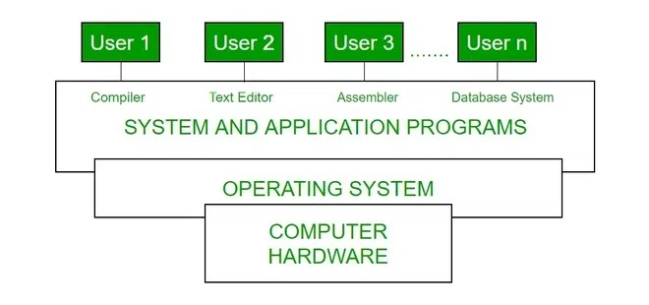

Every computer must have an operating system to run other programs. The operating system coordinates the use of the hardware among the various system programs and application programs for various users. It simply provides an environment within which other programs can do useful work.  
  
An OS is a package of some programs that runs on a computer machine, allowing it to perform efficiently. It manages the simple tasks of recognizing input from the keyboard, managing files and directories on disk, displaying output on the screen and controlling peripheral devices.

## ****Goals of Operating System****

### Primary Goals

The primary goals of an operating system (OS) are to provide a easy to use and convenient environment for executing user programs.

1. **User Convenience :**It should be easy to use, providing a user-friendly interface and making it simple to interact with the system.
2. **Program Execution**: It facilitates the execution of user programs, providing the necessary environment and services for them to run**.**
3. **Resource Management**: The OS manages and allocates the computer's resources, including the CPU, memory, disk storage, and input/output devices, to ensure fair utilization.
4. **Security**: The OS protects the system and user data from unauthorized access, ensuring the confidentiality, integrity, and availability of information.

### Secondary Goals

1. **Efficient Resource Utilization**: It should aim to maximize the performance and utilization of computer resources like CPU, Memory and IO devices, ensuring that the system runs smoothly and efficiently.
2. **Reliability**: It should be robust and reliable, able to handle errors and exceptions gracefully, ensuring that the system continues to operate smoothly. It should be modular in design and easy to debug.

## List of Common Operating Systems

There are multiple types of operating systems each having its own unique features:

### ****Windows OS****

* **Developer**: Microsoft
* **Key Features**: User-friendly interface, software compatibility, hardware support, Strong gaming support.
* **Advantages**: Easy to use for most users, Broad support from third-party applications ,Frequent updates and support.
* **Typical Use Cases**: Personal computing, Business environment, Gaming.

### macOS

* **Developer**: Apple.
* **Key Features**: Sleek, intuitive user interface, Strong integration with other Apple products, Robust security features, High performance and stability.
* **Advantages**: Optimized for Apple hardware, Seamless experience across Apple ecosystem, Superior graphics and multimedia capabilities.
* **Typical Use Cases**: Creative industries (design, video editing, music production), Personal computing, Professional environments.

### Linux

* **Developer**: Community-driven (various distributions).
* **Key Features**: Open-source and highly customizable, Robust security and stability, Lightweight and can run on older hardware, Large selection of distributions (e.g., Ubuntu, Fedora, Debian).
* **Advantages**: Free to use and distribute, Strong community support, Suitable for servers and development environments.
* **Typical Use Cases**: Servers and data centers, Development and programming, Personal computing for tech enthusiasts.

### Unix

* **Developer:**Originally AT&T Bell Labs, various commercial and open-source versions available
* **Key Features:**Multiuser and multitasking capabilities, Strong security and stability, Powerful command-line interface, Portability across different hardware platforms
* **Advantages:**Reliable and robust performance, Suitable for high-performance computing and servers, Extensive support for networking
* **Typical Use Cases:**Servers and workstations, Development environments, Research and academic settings

## ****History of Operating System****

The operating system has been evolving through the years. The following table shows the history of OS.

| **Era** | **Key Developments** | **Examples** |
| --- | --- | --- |
| **1956** | The first Operating System was GM-NAA I/O in 1956 by General Motors. | GM-NAA I/O (1956) |
| **1960s** | IBM developed a time sharing system TSS/360 | OS/360, DOS/360 and TSS/360 |
| **1970s** | Unix popularized simplicity and multitasking; rise of personal computers with basic OSs. | Unix (1971), CP/M (1974) |
| **1980s** | GUI-based OSs gained traction; networking features became standard. | Apple Macintosh (1984), Windows (1985) |
| **1990s** | Open-source Linux emerged; GUIs in Windows and Mac OS improved. | Linux (1991), Windows 95 (1995) |
| **2000s-Present** | Mobile OSs dominated; cloud and virtualization technologies advanced computing. | iOS (2007), Android (2008) |

## ****Characteristics of Operating Systems****

Let us now discuss some of the important characteristic features of operating systems:

* **Device Management:**The operating system keeps track of all the devices. So, it is also called the Input/Output controller that decides which process gets the device, when and for how much time.
* **File Management:**It allocates and de-allocates the resources and also decides who gets the resource.
* **Job Accounting:**It keeps track of time and resources used by various jobs or users.
* **Error-detecting Aids:**These contain methods that include the production of dumps, traces, error messages and other debugging and error-detecting methods.
* **Memory Management:**It is responsible for managing the [primary memory](https://www.geeksforgeeks.org/primary-memory/)of a computer, including what part of it are in use by whom also check how much amount free or used and allocate process
* **Processor Management:**It allocates the processor to a process and then de-allocates the processor when it is no longer required or the job is done.
* **Control on System Performance:**It records the delays between the request for a service and the system.
* **Security:**It prevents unauthorized access to programs and data using passwords or some kind of protection technique.
* **Convenience:**An OS makes a computer more convenient to use.
* **Efficiency:**An OS allows the computer system resources to be used efficiently.
* **Ability to Evolve:**An OS should be constructed in such a way as to permit the effective development, testing and introduction of new system functions at the same time without interfering with service.
* **Throughput:**An OS should be constructed so that It can give maximum throughput (Number of tasks per unit time).

## Components of an Operating Systems

There are two basic components of an Operating System.

* [Shell](https://www.geeksforgeeks.org/difference-between-shell-and-kernel/)
* [Kernel](https://www.geeksforgeeks.org/kernel-in-operating-system/)

### Shell

Shell is the outermost layer of the Operating System and it handles the interaction with the user. The main task of the Shell is the management of interaction between the User and OS. Shell provides better communication with the user and the Operating System Shell does it by giving proper input to the user it also interprets input for the OS and handles the output from the OS. It works as a way of communication between the User and the OS.

### Kernel

The kernel is one of the components of the Operating System which works as a core component. The rest of the components depends on Kernel for the supply of the important services that are provided by the Operating System. The kernel is the primary interface between the Operating system and Hardware.

**Functions of Kernel**

The following functions are to be performed by the Kernel.

* It helps in controlling the System Calls.
* It helps in I/O Management.
* It helps in the management of applications, memory, etc.

**Types of Kernel**

There are four types of Kernel that are mentioned below.

* [Monolithic Kernel](https://www.geeksforgeeks.org/monolithic-kernel-and-key-differences-from-microkernel/)
* [Microkernel](https://www.geeksforgeeks.org/microkernel-in-operating-systems/)
* [Hybrid Kernel](https://www.geeksforgeeks.org/kernel-in-operating-system/)
* [Exokernel](https://www.geeksforgeeks.org/kernel-in-operating-system/)

# 2 -Unix File System

* Unix File System is a logical method of **organizing and storing** large amounts of information in a way that makes it easy to manage. A file is the smallest unit in which the information is stored. Unix file system has several important features. All data in Unix is organized into files. All files are organized into directories. These directories are organized into a tree-like structure called the file system. Files in Unix System are organized into multi-level hierarchy structure known as a directory tree. At the very top of the file system is a directory called “root” which is represented by a “/”. All other files are “descendants” of root.
* The Unix file system is a hierarchical file system used by Unix-based operating systems to store and organize files and directories. It is a tree-like structure that starts with a single directory called the root directory, which is denoted by a forward slash (/) character.
* The Unix file system uses a directory hierarchy that allows for easy navigation and organization of files. Directories can contain both files and other directories, and each file or directory has a unique name.
* Unix file system also uses a set of permissions to control access to files and directories. Each file and directory has an owner and a group associated with it, and permissions can be set to allow or restrict access to these entities.
* One of the most important features of the Unix file system is its support for symbolic links, which are pointers to other files or directories. This allows for flexible organization of files and directories without having to physically move them around.

**1. The "Everything is a File" Philosophy**

This is the cornerstone of the Unix file system. It means that not only are traditional data files (like text documents, images, or executable programs) treated as files, but so are:

* **Directories:** Special files that contain lists of other files and directories.
* **Hardware Devices:** Represented as special files in the /dev directory (e.g., /dev/sda for a hard drive, /dev/tty for a terminal, /dev/lp0 for a printer).
* **Inter-Process Communication (IPC) Mechanisms:** Such as named pipes (FIFOs) and sockets, which allow processes to communicate with each other.

This uniformity simplifies system calls and programming, as many operations (like read(), write(), open(), close()) can be applied consistently across different "types" of files.

**2. Hierarchical (Tree) Structure**

The Unix file system is organized in an inverted tree structure, starting from a single root directory:

* **The Root Directory (/):** This is the top-level directory, from which all other directories and files branch out. There is only one root directory in a Unix system, providing a unified and consistent entry point to the entire file system.
* **Branches and Leaves:** Directories act as branches, containing other directories (subdirectories) and files (leaves).
* **Pathnames:** Files and directories are accessed using unique pathnames that describe their location within this hierarchy.
  + **Absolute Pathnames:** Start from the root (/), e.g., /home/user/document.txt.
  + **Relative Pathnames:** Start from the current working directory, e.g., documents/report.pdf (if your current directory is /home/user).

**Common Top-Level Directories:** While the exact layout can vary slightly between Unix-like systems, some common standard directories include:

* /bin: Essential command binaries.
* /etc: Host-specific system-wide configuration files.
* /home: User home directories.
* /usr: User utilities and applications (historically "Unix System Resources").
* /var: Variable data files, such as logs, mail queues, etc.
* /dev: Device files.
* /tmp: Temporary files.

**3. Inodes (Index Nodes)**

Inodes are a fundamental data structure in the Unix file system. Every file and directory on a Unix file system has a unique **inode number**.

* **Metadata Storage:** An inode stores all the metadata (information *about* a file) except its name and actual data content. This metadata includes:
  + File type (regular, directory, symbolic link, device, etc.)
  + Permissions (access rights for owner, group, others)
  + Owner's User ID (UID) and Group ID (GID)
  + Size of the file in bytes
  + Timestamps (last access atime, last modification mtime, last inode change ctime)
  + Number of hard links pointing to this inode
  + Pointers to the actual data blocks on the disk where the file's content is stored.
* **Separation of Name and Data:** This inode structure separates the filename (which is stored in a directory entry) from the file's metadata and data. A directory entry simply maps a filename to an inode number.
* **Efficiency:** This separation allows for efficient organization and features like hard links.

#### **4. Types of Files**

Building on the "everything is a file" philosophy, Unix distinguishes several types of files:

* **Regular Files (-):** Contain actual data (text, executable programs, images, documents, etc.).
* **Directories (d):** Special files that list filenames and their corresponding inode numbers.
* **Symbolic Links (Soft Links) (l):** Pointers to other files or directories. They contain the path to the target file. Deleting the target makes the link "broken." Can span file systems.
* **Hard Links (no special indicator, appears as a regular file):** Direct entries to an inode. Multiple hard links can point to the same inode, meaning they are different names for the *exact same file content*. Deleting a hard link only removes one reference; the file content is deleted only when all hard links and the original directory entry are removed. Cannot span file systems.
* **Block Device Files (b):** Represent hardware devices that transfer data in fixed-size blocks (e.g., hard drives, CD-ROMs).
* **Character Device Files (c):** Represent hardware devices that transfer data one character at a time (e.g., keyboards, serial ports).
* **Named Pipes (FIFOs) (p):** Special files used for one-way inter-process communication.
* **Sockets (s):** Special files used for inter-process communication, often over a network.

#### **5. Access Rights (Permissions)**

Unix employs a robust permission system to control who can access files and how. Permissions are stored in the file's inode and apply to three categories of users:

* **Owner (u):** The user who owns the file.
* **Group (g):** The group that owns the file.
* **Others (o):** Everyone else on the system.

For each category, three types of access are defined:

* **Read (r):** Ability to view file content or list directory content.
* **Write (w):** Ability to modify file content or create/delete/rename files within a directory.
* **Execute (x):** Ability to run an executable file or traverse (enter) a directory.

These permissions are often seen in a 10-character string (e.g., -rwxr-xr--) or an octal representation (e.g., 754).

**File on Unix Operating System:**

* In Unix everything is treated as a file, even devices are also treated as a special file.
* All devices are represented by files called special files that are located in/dev directory.
* These are access in the same way as regular file.
* Device files has two category: 1)Block Special File , 2) Character Special File
* In Block Special File data gets transfer in terms of block. So it has characteristics similar to disk.
* In Character Special File data gets transfer by stream of bits in sequential order like keyboard.
* Every file on a Unix System has a Unique Inode.
* Processes access files by well defined set of system call.
* Files can be specifies by a character string called as path name.
* Each Pathname is unique and it is converted to an Inode.

**FILES :**

* **/***— The Root Directory***:**The root directory is the one from which all other directories branch off. The’ / ’ is the symbol for the root directory. In the root directory, only the root users have access to edit files in this directory. The root directory is the starting point for every file. A common error that is made is mistaking /root as the root directory, but they are both different, /root usually refers to the user’s home directory/.
* **/bin** *— Essential User Binaries***:** It is the directory that contains important user binaries, In other words, it contains the executable files for several common shell programs, like rm, ls, cd, mkdir, and others. These executable programs are located in this directory because they are still in binary format. These binary files are used by the operating system for system-related operations.
* **/boot***— Static Boot Files:* The */boot* directory contains files required for starting your system. In order to start the computer and bring the operating system into operational mode, the booting procedure uses a variety of hardware components and operating system files.
* **/dev** *— Device Files***:** as the name implies, it contains device files. they are not actually files because they do not reside in the computer. For example, if you plug in a new webcam or a USB pen drive into your machine, a new device entry will pop up here.
* **/etc***— Configuration Files***:** It is known as the system configuration directory. Examples of files in this directory include passwd, group, hosts, and others. The directory is typically owned by the root user and has permissions that only allow the root user to read and write to it. This is because the configuration files in this directory are critical to the operation of the system and should only be modified by the system administrator.
* **/home —** *Home folders:* In the Linux File system, each user gets a home directory that is created solely for the user. This directory contains user-specific configuration files and other user data. The files in this directory depend on the users’ preferences.
* **/lib***— Essential Shared Libraries***:** It is a system directory that contains shared libraries. Shared libraries are a cluster of pre-compiled code that executable binaries can use. The */lib* directory contains the essential shared libraries needed to boot the system and run the commands in the */bin* and */sbin* directories. The */lib* directory also contains the kernel modules.
* **/media***— Removable media***:** It is a system directory that contains mount points for removable media where various removable media devices like SD cards, USB disks, or DVDs get mounted. These removable media files can be found in the*/media* directory as subdirectories. These subdirectories are automatically formed. For instance, the media directory is automatically formed when a CD is inserted into a CD-ROM. You can browse the CD’s files by going to the */media* subdirectory.
* **/mnt** *— Temporary Mount Points:* It's not very popular nowadays. This was where storage devices and partitions were manually mounted.
* **/opt***— Optional Packages:* Additionally, Linux makes extensive use of add-on software packages. This directory is typically used by Linux distros to install software that is not part of the operating system kernel or core system libraries. The software here can be removed without causing any effect on the system.
* **/proc**—*Kernel & Process Files:*The */proc*directory provides information about the running kernel and processes, it also provides a way to access kernel data structures and process information.
* **/root —***Root Home Directory:*It serves as the home directory for the root user and is another essential directory in the Linux directory structure. The root user is also known as the administrator or superuser.
* **/run —***Application State Files:* All temporary files created or used for certain purposes, such as process IDs or connections, are kept in this directory. It is a mount point for runtime data. It is a new addition to the Linux file directory.
* **/sbin —***System Administration Binaries:* It is similar to the */bin* directory. The ‘s’ stands for sudo or super. The root user normally owns the*/sbin*directory, and the directory’s permissions only permit the root user to read, write, and execute files. This is due to the fact that the commands in the */sbin*directory are frequently used to alter the system, changes that could be detrimental if they are misused.
* **/srv —***Service Data***:**The */srv*directory is an important part of the Linux filesystem hierarchy for users who want to host services on their system. This directory contains various service-related information connected to the system or kernel. It is also used to store data for web servers, FTP servers, and other services
* **/tmp —***Temporary Files:*Many programs and third-party programs create temporary files when they begin to run. The */tmp* directory is home to such temporary files. The files automatically delete when the user restarts the system.
* **/usr —***User Binaries & Read-Only Data:*It is also called ”user system resources”. It contains the files and apps that are needed by users to run programs and access documentation.
* **/var —***Variable Data Files:* These are files that are created and modified by programs during normal operation and may change in size over time. It usually remains in read-only mode for normal operations.

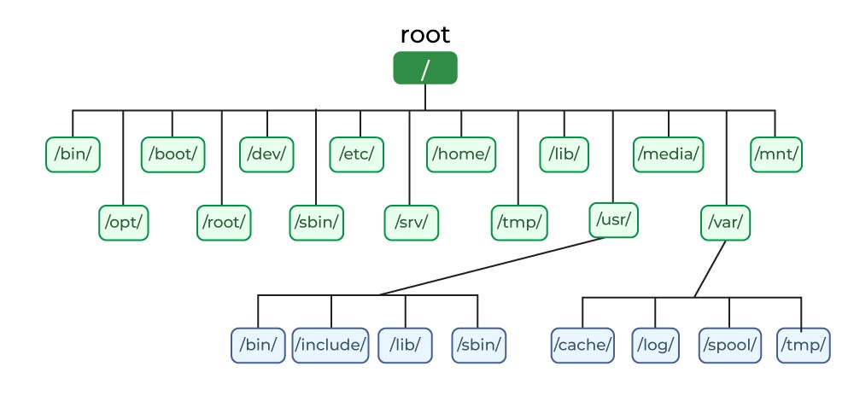

**Links:**

In the Unix file system, **links** are essential mechanisms that allow a single file or directory to be referenced by multiple names or in multiple locations within the file system hierarchy. They're like aliases or shortcuts, but they function in two distinct ways: **hard links** and **symbolic (or soft) links**.

## 1. Hard Links

A **hard link** is essentially an additional name or directory entry that points directly to an existing **inode**. Remember that an inode is the data structure that stores all the metadata about a file (like its permissions, owner, size, and location of its data blocks), but *not* its name.

Here's how they work:

* **Direct Pointer to Inode:** When you create a hard link, you're creating another directory entry that contains the *same inode number* as the original file. This means both the original filename and the new hard link are equally valid names for the exact same underlying file content and metadata.
* **Shared Content:** Because they point to the same inode, hard links share the exact same data blocks on the disk. Changing the content of the file through one name will reflect instantly when accessed through any other hard link.
* **Reference Count:** Each inode has a "hard link count" (or reference count) which tracks how many directory entries point to it. When you create a hard link, this count increments. When you delete a filename (using rm), the corresponding directory entry is removed, and the hard link count for that inode decrements. The actual file data is only truly deleted from the disk when its hard link count drops to **zero** and no process has the file open.
* **Limitations:**
  + **Cannot cross file systems:** Hard links must reside on the *same physical file system* as the original file because inode numbers are unique only within a given file system.
  + **Cannot link directories (usually):** Unix typically disallows hard-linking directories to prevent the creation of cycles in the file system tree, which could confuse utilities and lead to infinite loops.

**Analogy:** Imagine a book without a title on its cover. The library might create two catalog cards, each with a different title, both pointing to that same physical book on the shelf. If you remove one catalog card, the book is still there and accessible via the other card. Only when all catalog cards are removed is the book taken off the shelf.

## 2. Symbolic Links (Soft Links)

A **symbolic link** (often called a **soft link** or **symlink**) is a special type of file that contains a **pathname** to another file or directory. It acts more like a shortcut or an alias commonly found in other operating systems.

Here's how they work:

* **Pointer to a Pathname:** A symbolic link is a distinct file with its own unique inode. Its data content is simply the *path* to the target file or directory it's linking to.
* **Indirect Reference:** When you access a symbolic link, the operating system reads the path stored within it and then redirects your request to that target path.
* **Independent Existence:** Because it's a separate file, deleting the *target* file or directory does *not* delete the symbolic link itself. However, the symbolic link will become "broken" or "dangling" because it points to a non-existent location.
* **Flexibility:**
  + **Can cross file systems:** Symbolic links can point to files or directories located on different physical file systems.
  + **Can link directories:** They can be used to link to directories, providing flexible organization and easy access to deeply nested or frequently used directories from various locations.
  + **Can link to non-existent files:** You can create a symbolic link to a file that doesn't exist yet (though it will be broken until the target is created).

**Analogy:** Imagine a sticky note that says "See 'The Great Novel' in Section B, Shelf 3." This sticky note is a symbolic link. If someone removes "The Great Novel" from the shelf, the sticky note is still there, but it no longer leads you to a book.

### Key Differences Summarized

| Feature | Hard Link | Symbolic (Soft) Link |
| --- | --- | --- |
| **Type** | Another name for the same inode | A separate file that stores a path to another file |
| **Inode** | Shares the *same* inode number as the original | Has its *own* unique inode number |
| **Data Deletion** | File data deleted only when all hard links are removed (ref count = 0) | File data deleted if the target file is removed; link becomes broken |
| **Cross Filesystem** | No, must be on the same file system | Yes, can span different file systems |
| **Link Directories** | No (typically) | Yes |
| **Appearance (ls -l)** | Appears as a regular file (-) | Clearly indicated with l and shows target (lrwxrwxrwx... -> target) |

Export to Sheets

Understanding links is crucial for navigating, organizing, and managing files efficiently in a Unix environment, especially for system administrators and developers.

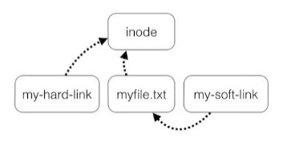

**Types:**

Okay, let's detail the various **Types of Files** in the Unix file system. This is a core concept that embodies the "everything is a file" philosophy, meaning that Unix represents a wide range of entities—from data to hardware devices and communication channels—as files.

When you use the ls -l command, the very first character of the output indicates the file type.

Here are the primary types of files in the Unix file system:

### Regular Files

* + **Indication in ls -l:** - (a hyphen)
  + **Description:** These are the most common type of files. They contain user data, program code, text documents, images, audio, video, executable binaries, scripts, etc. The operating system simply treats them as a sequence of bytes and does not interpret their content. It's up to the application program to understand the data format.
  + **Examples:** my_document.txt, report.pdf, program.c, a.out (an executable binary), image.jpg.

### Directories

* + Indication in ls -l: d
  + **Description:** Directories are special files that contain a list of filenames and their corresponding inode numbers. They are used to organize files and other directories into a hierarchical (tree-like) structure. They don't contain the actual data of the files listed within them, only pointers (inode numbers) to those files.
  + **Examples:** /home, /usr/bin, /etc, my_folder.

### Symbolic Links (Soft Links)

* + **Indication in ls -l:** l
  + **Description:** A symbolic link is a special file that contains a *pathname* to another file or directory. It acts like a shortcut or an alias. When you access a symbolic link, the system follows the path stored inside it to the actual target file or directory.
  + **Key Characteristics:**
    - Has its own unique inode.
    - Can point to files or directories on different file systems.
    - Can point to a non-existent file (becomes a "broken" or "dangling" link if the target is deleted).
  + **Example:** lrwxrwxrwx 1 user group 15 Jul 1 11:00 my_shortcut -> /path/to/original_file.txt

### Hard Links

* + **Indication in ls -l:** - (appears as a regular file; its nature as a hard link is determined by its inode number being shared and the hard link count in ls -l output being greater than 1).
  + **Description:** A hard link is a direct entry in a directory that points to an existing inode. It means that multiple names (filenames) can refer to the *exact same underlying file content and metadata*. There's no "original" file; all hard links are equally valid names for the same data. The file data is only truly removed when all hard links to its inode are deleted and no process has it open.
  + **Key Characteristics:**
    - Shares the *same* inode number as the original file.
    - Cannot cross file system boundaries (must be on the same partition).
    - Cannot be used to link directories (to prevent recursive loops).
  + **Example:** If file1.txt and link_to_file1.txt both point to inode 123, they are hard links. ls -l would show -rw-r--r-- 2 user group ... file1.txt and -rw-r--r-- 2 user group ... link_to_file1.txt (note the '2' in the link count).

### Block Device Files

* + **Indication in ls -l:** b
  + **Description:** These files represent hardware devices that transfer data in fixed-size blocks. They are typically used for storage devices like hard drives, solid-state drives, CD-ROM drives, etc. When a program reads from or writes to a block device file, it's directly interacting with the hardware at a block level.
  + **Examples:** /dev/sda (first SATA hard drive), /dev/hda (first IDE hard drive), /dev/sdb1 (first partition of the second SATA drive).

### Character Device Files

* + **Indication in ls -l:** c
  + **Description:** These files represent hardware devices that transfer data one character (or byte) at a time, without buffering. They are used for devices like keyboards, mice, serial ports, printers, and terminals.
  + **Examples:** /dev/tty (the controlling terminal for the current process), /dev/console, /dev/lp0 (first parallel printer port).

### Named Pipes (FIFOs - First-In, First-Out)

* + **Indication in ls -l:** p
  + **Description:** Named pipes are special files used for inter-process communication (IPC). Data written to one end of the pipe can be read from the other end. They allow unrelated processes to communicate in a one-way (FIFO) manner using the file system as an intermediary. They behave like traditional pipes (|) but have a name in the file system.
  + **Example:** Used when piping output from one command to another, but with a persistent file system entry.

### Sockets

* + **Indication in ls -l:** s
  + **Description:** Sockets are special files used for inter-process communication, primarily over a network (but also for local communication). They serve as endpoints for communication channels, allowing processes to send and receive data. Unix domain sockets (local sockets) appear in the file system.
  + **Example:** Used by local network services or databases to allow communication between processes on the same machine (e.g., /var/run/mysqld/mysqld.sock).

Understanding these different file types is crucial for effectively working with and administering Unix-like systems, as it clarifies how the OS abstracts various resources and communication channels into a unified file system interface.

**Inode:**

In Unix-based operating systems, each file is identified by an Inode, which stands for Index Node. Inodes are special data structures created when the file system is initialized. The total number of inodes determines the maximum number of files and directories that the file system can hold.

An inode contains essential information about a file, such as its size, ownership, permissions, and pointers to the data blocks. When a file system is created, a fixed number of inodes is allocated, typically about 1% of the total disk space is reserved for the inode table. This allocation limits the number of files that can be stored, regardless of the available disk space.

## Key Information Stored in an Inode

An inode contains important metadata about a file or directory. It contains the following information:

* 1. File Names of 14 Bytes and Corresponding Inodes of 2 Bytes. For example,

| File name 1 | i-node 1 |
| --- | --- |
| File name 2 | i-node 2 |
| Directory name 1 | i-node 3 |

* Ownership Information
  + Numeric UID of the owner.
  + Numeric GUID of the owner.
* File Size and Type
  + Size of the file in Bytes
  + File type: eg. regular, directory, device etc.
* Timestamps
  + Date and Time of Last modification of the file data.
  + Date and Time of Last access of file data.
  + Date and Time of Last change of the I-node.
* Administrative information like permissions, access control settings, and other metadata related to the file.
* Data Block Pointers
  + A number of direct blocks (typically 12) that contains the first 12 blocks of the files.
  + A single indirect pointer that points to a disk block which in turn is used as an index block, if the file is too big to be indexed entirely by the direct blocks.
  + A double indirect pointer that points to a disk block which is a collection of pointers to disk blocks which are index blocks, used if the file is too big to **beindexed**by the direct and single indirect blocks.
  + A triple indirect pointer that points to an index block of index blocks of **index blocks**.

## What is the Inode Total Size and Its Impact on File Storage

* Number of disk block address possible to store in 1 disk block = (Disk Block Size / Disk Block Address).
* Small files need only direct blocks, so there is little waste in space or extra disk reads in those cases. **Medium-sized** files may use indirect blocks. Only large files use double or triple indirect blocks, which is reasonable since those files are large anyway. The disk is now broken into two different types of blocks: **Inode and Data Blocks**.
* There must be some way to determine where the Inodes are, and to keep track of free Inodes and disk blocks. This is done by a **Superblock**. **Superblock**is located at a fixed position in the file system. The Superblock is usually replicated on the disk to avoid catastrophic failure in case of corruption of the main Superblock.

The superblock stores critical metadata:

* + total blocks,
  + total inodes,
  + free block map,
  + free inode map,
  + filesystem state, etc.

Index allocation schemes suffer from some of the same performance problems. As does linked allocation. For example, the index blocks can be cached in memory, but the data blocks may be spread all over a partition. • Indexed allocation (like the inode’s index block or indirect block) avoids sequential traversals, but its data blocks may still be scattered, causing poor locality and higher seek times. Similarly, linked allocation (chaining blocks) suffers from fragmentation and multiple disk seeks. That’s why block caching is crucial.

## Breaking Down the Inode Structure

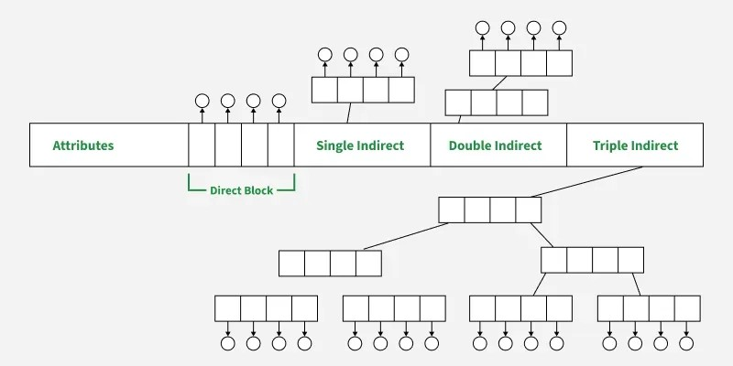

### ****Direct Block****

* The **direct block** refers to pointers stored directly in the inode, which point directly to the actual data blocks that hold the file's content. These are the first-level pointers that allow the file system to quickly access the data of small files.
* For example, if a file is small enough, the inode might have a set of pointers (often 12) that directly address the first few data blocks of the file without needing any additional layers of indirection. This makes accessing small files efficient.

### ****Single Indirect Block****

* If the file is larger than what the direct blocks can address, the **single indirect block** comes into play. Instead of directly pointing to data blocks, the inode stores a pointer to another block called the **indirect block**.
* The indirect block, in turn, contains pointers to the actual data blocks of the file. This provides additional flexibility for the file system to handle files that are too large to fit within the capacity of the direct blocks.

### ****Double Indirect Block****

* When a file becomes even larger, the **double indirect block** is used. This is a more advanced level of indirection where the inode points to a block that contains pointers to **single indirect blocks**.
* Each of these single indirect blocks, as described above, will contain pointers to the data blocks of the file. The double indirection effectively extends the file system’s ability to handle even larger files by adding another layer of pointers.

### ****Triple Indirect Block****

* For **extremely large files**, the **triple indirect block** is used. It points to a block that contains pointers to **double indirect blocks**. These, in turn, contain pointers to **single indirect blocks**, and the single indirect blocks finally point to the data blocks.
* This multi-layered indirection system allows the file system to address massive files, even when the file size exceeds the typical limits of direct and indirect addressing.

### ****Attribute Section****

In addition to storing pointers to data blocks, an inode also stores important **metadata** or attributes about the file. These attributes may include:

* **File size**: The size of the file in bytes.
* **Permissions**: Information about who can read, write, or execute the file.
* **File type**: Whether the file is a regular file, directory, symbolic link, etc.
* **Timestamps**: When the file was last accessed, modified, or when the inode was last changed.
* **Owner and group**: Information about the file's owner (user ID) and the associated group (group ID).

1. **File Type:**
   * Indicates whether it's a regular file, directory, symbolic link, block device, character device, named pipe, or socket. (e.g., - for regular, d for directory, l for symbolic link).
2. **Permissions (Access Rights):**
   * Defines who can read, write, or execute the file/directory. This is broken down for the owner, the group, and others (e.g., rwxr-xr-- or 754).
3. **Owner and Group IDs:**
   * The User ID (UID) of the user who owns the file.
   * The Group ID (GID) of the group associated with the file.
4. **Size of the File:**
   * The total number of bytes in the file's data content.
5. **Timestamps:**
   * **atime (Access Time):** The last time the file's content was read.
   * **mtime (Modification Time):** The last time the file's content was changed.
   * **ctime (Change Time):** The last time the file's inode metadata was changed (e.g., permissions, owner, or mtime).
6. **Number of Hard Links:**
   * A count of how many directory entries (filenames) currently point to this specific inode. When this count drops to zero, and no process has the file open, the file's data blocks are considered free and can be reused.
7. **Pointers to Data Blocks:**
   * Crucially, the inode contains pointers (disk addresses) that tell the file system where the actual content of the file (its bytes) is stored on the physical storage device (hard drive, SSD, etc.). For larger files, these pointers can be direct, indirect, or even double/triple indirect to handle very large file sizes efficiently.

### The Relationship: Filename, Inode, and Data Blocks

This is where the power of inodes becomes clear:

1. **Directory Entry:** When you create a file (e.g., my_document.txt), its name is stored in a **directory**. A directory is essentially a special type of file that contains a list of filenames, and for each filename, it stores its corresponding **inode number**.
2. **Inode Lookup:** When you try to access a file by its name (e.g., cat my_document.txt), the operating system first looks up my_document.txt in the relevant directory. It finds the associated inode number.
3. **Inode Retrieval:** Using the inode number, the OS then retrieves the actual inode structure from a special area on the disk called the "inode table."
4. **Data Access:** From the inode, the OS gets all the metadata (permissions, owner, size, etc.) and, most importantly, the pointers to the **data blocks** where the file's content is physically stored. It then reads those data blocks to provide you with the file's content.

### Why are Inodes Important?

* **Decoupling Name from Data:** This is perhaps the most significant benefit. It allows for multiple names (hard links) to point to the same file content without duplicating the data. Deleting a name only removes a reference; the file is truly gone only when its inode's hard link count reaches zero.
* **Efficiency:** The inode table provides a quick lookup for file metadata, separate from the data blocks.
* **Consistency:** All critical information about a file is centrally located in its inode.
* **Flexibility:** It supports the "everything is a file" model and facilitates advanced features like symbolic and hard links.
* **Filesystem Limits:** The number of available inodes typically determines the maximum number of files and directories that can be created on a given file system partition, even if there's plenty of free disk space for data.

Understanding inodes is crucial for truly grasping how the Unix file system works, especially when dealing with links, disk usage, and file management.

**Access Rights :**

### Purpose of Access Rights

The primary purpose of Unix file permissions is to:

1. **Protect Data:** Prevent unauthorized users from reading, modifying, or deleting sensitive information.
2. **Maintain System Integrity:** Ensure that critical system files and executables are not accidentally or maliciously altered.
3. **Facilitate Multi-User Environments:** Allow multiple users to share a system securely, with each user (and their programs) having appropriate access to their own files while being restricted from others' files.

In Unix-like operating systems, file system access rights, or permissions, control who can access and modify files and directories. These permissions are categorized into three access levels: read, write, and execute, and applied to three distinct user categories: the file owner, the file's group, and all other users (referred to as "others").

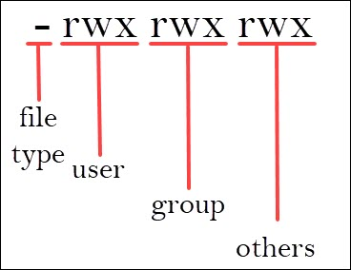

Okay, let's break down **Access Rights (Permissions)** in the Unix file system. This is a crucial security and management mechanism that controls who can do what with files and directories.

### Purpose of Access Rights

The primary purpose of Unix file permissions is to:

1. **Protect Data:** Prevent unauthorized users from reading, modifying, or deleting sensitive information.
2. **Maintain System Integrity:** Ensure that critical system files and executables are not accidentally or maliciously altered.
3. **Facilitate Multi-User Environments:** Allow multiple users to share a system securely, with each user (and their programs) having appropriate access to their own files while being restricted from others' files.

### How Permissions are Structured

### Unix permissions are defined for three distinct categories of users and apply three types of access.

### A. Categories of Users

Permissions are set for these three entities:

1. **Owner (u - user):**
   * The specific user who owns the file or directory. By default, this is the user who created it.
   * The owner has the most control and can usually change the permissions themselves.
2. **Group (g - group):**
   * A designated group of users. All members of this group share the permissions assigned to the group.
   * This is useful for collaboration, allowing a team to work on files without giving access to everyone else on the system.
3. **Others (o - others / world):**
   * Everyone else on the system who is not the owner and not a member of the file's owning group.
   * This category typically has the most restrictive permissions.

### B. Types of Access (Permissions)

For each of the above user categories, you can grant or deny three fundamental types of access:

1. **Read (r):**
   * **For a file:** Allows viewing the content of the file (e.g., cat, more, less).
   * **For a directory:** Allows listing the contents of the directory (i.e., seeing what files and subdirectories are inside with ls). *Note: To actually access files within that directory, execute permission on the directory is also required.*
2. **Write (w):**
   * **For a file:** Allows modifying the content of the file, appending to it, or deleting the file itself.
   * **For a directory:** Allows creating new files or subdirectories within it, deleting existing files or subdirectories within it, or renaming files/subdirectories within it. *Note: Deleting a file requires write permission on its containing directory, not on the file itself.*
3. **Execute (x):**
   * **For a file:** Allows running the file as a program or script.
   * **For a directory:** Allows "entering" or "traversing" the directory (e.g., using cd to change into it). This permission is crucial for navigating the file system hierarchy. Without x on a directory, even if you have r, you cannot access its contents beyond just listing their names.

### Representation of Permissions

Permissions are commonly represented in two ways:

### Symbolic (rwx) Representation

When you use ls -l (long listing), the permissions are displayed in a 10-character string:

-rwxr-xr-- 1 owner group 1024 Jul 1 15:00 myfile.txt

Let's break down the first 10 characters:

* + **Character 1:** Indicates the **file type**.
    - - : Regular file
    - d : Directory
    - l : Symbolic link
    - b : Block device file
    - c : Character device file
    - p : Named pipe (FIFO)
    - s : Socket
  + **Characters 2-4 (Owner):** Permissions for the file's owner.
    - rwx: Read, Write, Execute
  + **Characters 5-7 (Group):** Permissions for the file's owning group.
    - r-x: Read, Execute (no write)
  + **Characters 8-10 (Others):** Permissions for everyone else.
    - r--: Read (no write, no execute)

So, -rwxr-xr-- means:

* + It's a regular file.
  + The owner can Read, Write, and Execute.
  + The group can Read and Execute.
  + Others can only Read.

### Numerical (Octal) Representation

Permissions can also be represented using a three-digit (sometimes four-digit for special permissions) octal number. Each permission type is assigned a value:

* + r (Read) = **4**
  + w (Write) = **2**
  + x (Execute) = **1**
  + - (No permission) = **0**

To get the octal value for each category (owner, group, others), you sum the values of the granted permissions:

* + rwx = 4+2+1=7
  + r-x = 4+0+1=5
  + r-- = 4+0+0=4

Thus, the example -rwxr-xr-- is numerically represented as 754.

### Commands for Managing Permissions

* **chmod (Change Mode):** Used to change the permissions of a file or directory.
  + **Symbolic Mode:** chmod u+w filename (add write permission for owner), chmod go-rwx filename (remove all permissions for group and others).
  + **Octal Mode:** chmod 755 filename (owner rwx, group rx, others rx).
* **chown (Change Owner):** Used to change the owner of a file or directory.
  + chown newuser filename
  + chown newuser:newgroup filename
* **chgrp (Change Group):** Used to change the group of a file or directory.
  + chgrp newgroup filename

### Special Permissions (Briefly for MTech Context)

For advanced contexts, be aware of "special permissions" (often indicated by a fourth digit in the octal representation or specific characters in ls -l output):

* **Setuid (Set User ID) (s in owner's 'x' spot):** When an executable file with setuid permission is run, it executes with the privileges of the *file's owner*, not the user running it. This is used for programs like passwd that need temporary root privileges.
* **Setgid (Set Group ID) (s in group's 'x' spot):**
  + For an executable: Runs with the privileges of the *file's group*.
  + For a directory: New files/directories created within it inherit the *group ownership* of the parent directory, not the primary group of the user creating them. Useful for shared directories.
* **Sticky Bit (t in others' 'x' spot):**
  + Primarily for directories: Users can only delete or rename files/directories they own within that directory, even if they have write permission on the directory. The /tmp directory often has the sticky bit set.

Understanding Unix access rights is fundamental for system administration, security, and developing applications that interact with the file system securely.

**System Calls :**

Okay, let's explain **System Calls** specifically in the context of the **Unix File System**. This is a crucial concept that bridges the gap between your applications and the core operating system, especially when those applications need to interact with files and directories.

### What are System Calls (Brief Recap)?

At a fundamental level, **System Calls** are the programmatic interface to the operating system's kernel. They are requests made by a user-level program to the kernel to perform a privileged, low-level operation or to access a protected resource.

**Why are they necessary?** User programs run in a restricted **"user mode,"** where they cannot directly access hardware, manage memory, or perform critical system functions. The OS kernel, on the other hand, runs in a privileged **"kernel mode"** with full control over the hardware and system resources. System calls provide a controlled and safe way for user programs to request these privileged operations from the kernel.

### System Calls in the Context of the Unix File System

The Unix file system is managed entirely by the OS kernel. This means that any operation an application wants to perform on a file or directory—whether it's creating one, reading from it, writing to it, changing its permissions, or even just checking its existence—**must go through a system call.**

Here's why and how:

1. **Protection and Security:**
   * The file system resides on physical storage devices, which are hardware resources. Direct access by user programs could lead to data corruption, security breaches, or system instability.
   * The kernel's file system manager ensures that access rights (permissions) are enforced and that operations are performed correctly and securely. User programs *cannot* bypass these checks.
2. **Abstraction and Consistency:**
   * System calls abstract away the complexities of the underlying hardware (disk drives, controllers, different file system formats like Ext4, XFS, etc.). An application simply requests to "open a file" or "read bytes," and the kernel handles all the intricate details of interacting with the physical disk.
   * This provides a consistent interface for interacting with all file types (regular files, directories, devices, pipes, sockets), reinforcing the "everything is a file" philosophy.
3. **Resource Management:**
   * The kernel manages disk space, caching, and buffering. System calls allow user programs to request these resources, and the kernel allocates them efficiently and fairly among competing processes.

**How File System System Calls Work (Simplified Flow):**

1. A user-level program (e.g., a C program, a Python script, or even a command-line utility like cat) needs to perform a file operation (e.g., open a file, read from it).
2. The program calls a standard library function (e.g., fopen(), fread() from C's stdio.h or equivalent in other languages). These library functions are *wrappers* around system calls.
3. The library function prepares the necessary arguments and then initiates a **software interrupt** or a special instruction (often called a trap) to switch the CPU from user mode to kernel mode.
4. The kernel receives the trap, identifies which specific system call was requested (e.g., open, read), and validates the arguments and permissions.
5. If authorized, the kernel performs the requested operation (e.g., finds the file's inode, accesses the data blocks on disk).
6. The kernel then returns the result (e.g., a file descriptor, the number of bytes read, an error code) to the user program, and the CPU switches back to user mode.

### Common Unix File System Related System Calls

Here are some of the most frequently used system calls for interacting with the Unix file system:

* **open():** Used to open an existing file or create a new one. It returns a **file descriptor** (a small integer) that is used in subsequent operations.
  + Example: fd = open("/path/to/file.txt", O_RDWR | O_CREAT);
* **close():** Closes an open file descriptor, releasing the resources associated with it.
  + Example: close(fd);
* **read():** Reads a specified number of bytes from an open file descriptor into a buffer in the user program's memory.
  + Example: bytes_read = read(fd, buffer, sizeof(buffer));
* **write():** Writes a specified number of bytes from a buffer in the user program's memory to an open file descriptor.
  + Example: bytes_written = write(fd, data, strlen(data));
* **lseek():** Changes the current read/write offset (position) within an open file.
  + Example: lseek(fd, 100, SEEK_SET); (move to byte 100 from start)
* **stat(), fstat(), lstat():** Retrieve file metadata (information from the inode) such as file type, permissions, size, owner, and timestamps.
  + stat(): Takes a pathname.
  + fstat(): Takes a file descriptor.
  + lstat(): For symbolic links, returns information about the link itself, not the target.
* **link():** Creates a hard link to an existing file.
  + Example: link("/path/to/original", "/path/to/hardlink");
* **symlink():** Creates a symbolic link to a file or directory.
  + Example: symlink("/path/to/target", "/path/to/symlink");
* **unlink():** Deletes a name from the file system. For hard links, it decrements the inode's link count. If the link count reaches zero and no process has the file open, the file's data blocks are freed.
  + Example: unlink("/path/to/file_to_delete");
* **mkdir():** Creates a new directory.
* **rmdir():** Deletes an empty directory.
* **chmod():** Changes the permissions (access rights) of a file or directory.
* **chown():** Changes the owner and/or group of a file or directory.

By providing this well-defined set of system calls, the Unix kernel gives applications powerful, yet secure and abstracted, mechanisms to manage and interact with the file system.

**Overview of Unix Kernels :**

### What is a Kernel?

The **kernel** is the central part of an operating system. It's the first program loaded when a computer starts (after the bootloader) and remains in memory throughout the system's operation. It acts as the bridge between the applications and the hardware, managing all low-level system resources.

The kernel operates in **kernel mode (or supervisor mode)**, a privileged state that grants it full access to all hardware and system memory. User applications, in contrast, run in **user mode**, with limited privileges, and must make **system calls** to request services from the kernel.

### Overview of Unix Kernels

Unix kernels (and their descendants like Linux, macOS, BSD, Solaris, AIX, etc.) share a common heritage and design philosophy, though they have evolved over time.

### 1. Core Responsibilities of a Unix Kernel

A Unix kernel is responsible for:

* **Process Management:**
  + Creating, scheduling (deciding which process runs when), terminating, and managing processes.
  + Handling process synchronization and inter-process communication (IPC) mechanisms (e.g., pipes, message queues, shared memory, semaphores).
* **Memory Management:**
  + Allocating and deallocating memory to processes.
  + Implementing virtual memory, paging, and swapping to optimize RAM usage and isolate processes.
  + Managing the kernel's own memory.
* **File System Management:**
  + Managing files and directories on storage devices.
  + Implementing file system structures (like inodes) and enforcing permissions.
  + Buffering and caching file data for performance.
* **Device Management (I/O Management):**
  + Controlling hardware devices (disks, network cards, keyboards, printers, etc.) through device drivers.
  + Handling I/O requests from user applications.
  + Managing device access and interrupts.
* **System Call Interface:**
  + Providing a well-defined set of system calls (like open(), read(), fork(), exec(), exit()) that user applications can use to request kernel services.
  + Handling the transition between user mode and kernel mode.

### 2. Monolithic Kernel Architecture (Traditional Unix & Linux)

The most common architecture for Unix kernels (including Linux) is **monolithic**.

* **Characteristics:**
  + **All core services** (process management, memory management, file system, device drivers) run together in a **single, large kernel space** in kernel mode.
  + This means all kernel components share the same address space and can directly call functions within each other.
* **Advantages:**
  + **High performance:** Direct function calls between components are fast, as there's no overhead of message passing between separate processes.
  + **Simplicity of design (initially):** Easier to design and implement a single, unified codebase.
* **Disadvantages:**
  + **Large size:** The kernel can become very large and complex.
  + **Less modular:** A bug in one part of the kernel can potentially crash the entire system because all components share the same address space.
  + **Difficult to maintain and extend:** Adding new features or device drivers often requires recompiling the entire kernel. (Though modern monolithic kernels like Linux use *loadable kernel modules* to mitigate this).

#### 3. Microkernel Architecture (e.g., MINIX, some macOS components)

While traditional Unix kernels are monolithic, the concept of a microkernel gained popularity as an alternative.

* **Characteristics:**
  + Only the **absolute minimum essential services** (e.g., inter-process communication, basic memory management, fundamental scheduling) reside in the kernel space.
  + Other services (file systems, device drivers, network protocols) run as separate **user-space processes** (servers).
* **Advantages:**
  + **Increased reliability and stability:** A bug in a user-space driver or file system server won't crash the entire kernel.
  + **Greater modularity:** Easier to develop, debug, and replace individual components without affecting the rest of the system.
  + **Better security:** Each component runs in its own address space.
* **Disadvantages:**
  + **Performance overhead:** Communication between user-space servers and the microkernel often involves message passing, which is slower than direct function calls in a monolithic kernel due to context switches.
  + **Complexity of IPC:** Designing efficient inter-process communication mechanisms is challenging.

#### 4. Hybrid (Modular Monolithic) Kernels (e.g., Modern Linux)

Modern Unix kernels, particularly Linux, often employ a **hybrid** approach, which is essentially a **modular monolithic kernel**:

* They maintain the monolithic structure for core services (for performance reasons).
* However, they support **Loadable Kernel Modules (LKMs)**. This allows device drivers, new file systems, and other kernel functionalities to be loaded and unloaded into the kernel's address space at runtime *without* requiring a full kernel recompilation and reboot. This significantly improves flexibility and maintainability.

#### 5. Portability and the C Language

A defining characteristic of Unix kernels (and their success) is their emphasis on **portability**. Unix was famously rewritten in the **C programming language** by Dennis Ritchie. This move away from assembly language made Unix kernels highly portable across different hardware architectures, contributing immensely to their widespread adoption and the development of numerous Unix variants.

In summary, a Unix kernel is the powerful, resource-managing core of the operating system, predominantly built on a monolithic architecture (often with modern modular enhancements) and written in C to ensure portability. It serves as the privileged intermediary between all user applications and the computer's underlying hardware.

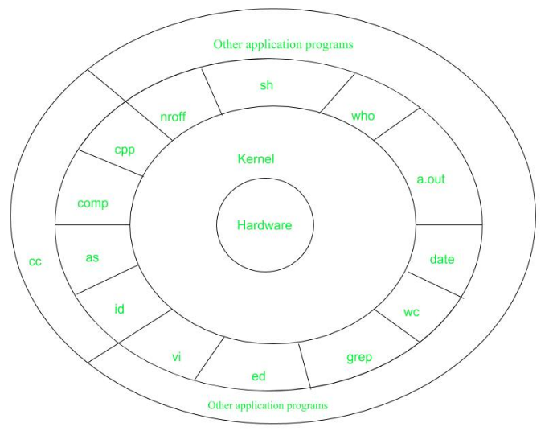 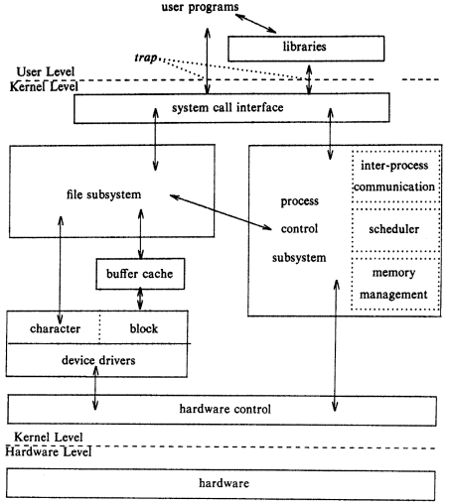

Here's an explanation of **Unix Kernel Implementation**, structured for a 6-mark answer, focusing on the key aspects of how it's built:

### Unix Kernel Implementation

The implementation of a Unix kernel refers to the concrete code, data structures, and mechanisms that enable the operating system's core to manage hardware and provide services.

1. **Primary Programming Languages:**
   * Predominantly written in **C**, offering low-level control over hardware and high portability across different architectures.
   * A small, critical portion uses **assembly language** for machine-specific tasks like initial boot-up, context switching, and direct CPU register manipulation.
2. **Component-Based Design with Data Structures:** The kernel's functionalities are realized through specific C data structures and algorithms:
   * **Process Management:** Each process is represented by a **Process Control Block (PCB)** (a C struct) containing its state, CPU registers, and resource information. Schedulers (C functions) manage these PCBs to allocate CPU time.
   * **Memory Management:** Implemented using **page tables** (C data structures for virtual-to-physical address mapping) and C algorithms for memory allocation, paging, and swapping.
   * **File System Management:** Relies on **Inodes** (C structs storing file metadata and pointers to data blocks). The **Virtual File System (VFS)**, a C layer, provides a unified interface for various file system types.
   * **Device Management:** Handled by **device drivers** (C code modules) that communicate directly with hardware and manage I/O operations and interrupts.
3. **System Call Interface:** The kernel provides a well-defined **system call interface** for user applications to request privileged services. These system calls are implemented as C functions within the kernel, accessed via a **system call table** and a hardware **trap** mechanism that transitions the CPU from user to kernel mode.
4. **Concurrency and Protection:** Unix kernels are **reentrant**, allowing multiple processes to execute kernel code. To ensure data integrity, the kernel uses **synchronization primitives** (e.g., spinlocks, mutexes) implemented in C. It also leverages **hardware support** (like MMUs) to enforce memory protection and isolate processes.
5. **Modular Extensibility (Hybrid Approach):** Modern Unix kernels (like Linux) employ a **modular monolithic** design. This means core services are integrated, but functionalities like device drivers can be implemented as **Loadable Kernel Modules (LKMs)**. These are separate C code units that can be dynamically loaded/unloaded at runtime, enhancing flexibility and maintainability without requiring a full kernel reboot.

This comprehensive implementation ensures the kernel's robustness, efficiency, and secure management of system resources.

**Implementation Details:**

* The kernel code is typically written in C (and sometimes assembly language).
* The kernel is loaded into memory during system boot and remains active throughout the system's operation.
* The kernel uses various data structures and algorithms to manage processes, memory, and other resources.
* Kernel routines can be activated through system calls, exceptions, interrupts, or by kernel threads.

# ****Reentrant Kernels in UNIX****

✅ A **reentrant kernel** is a type of kernel that allows multiple processes to enter the kernel code simultaneously without interfering with each other.

👉 In other words, the kernel code can be **safely shared** among processes because it does not maintain persistent state in global variables between calls, or it protects such shared state carefully.

**Why is this important?**

* In **non-reentrant kernels** (sometimes called monolithic or non-preemptive kernels), only one process can be in kernel mode at a time. If another process traps into the kernel, it has to wait.
* A **reentrant kernel** allows concurrent execution of system calls from different processes or even nested interrupts, improving system throughput and responsiveness.

# ****Key Features of Reentrant Kernels****

✅ **Code is read-only** — so it can be shared among processes  
✅ **Data is kept separate per process** — avoiding conflicts  
✅ Supports **interrupt handling** even while another process is executing in kernel mode  
✅ Allows true **concurrent process execution** in multiprocessor or multi-core systems

# ****Example in UNIX****

Classic UNIX kernels (Version 6, Version 7) were not fully reentrant; they disabled interrupts while running in kernel mode to simplify design.

Modern UNIX-like systems (e.g., Linux, BSD) are **reentrant**, meaning:

* kernel code is reentrant
* data structures are protected with synchronization mechanisms like **spinlocks** or **semaphores**
* supports **preemption** even inside the kernel

# ****In short****

👉 **Reentrant kernel** = kernel code that can be safely executed by multiple processes (or multiple CPUs) at the same time.  
👉 It is essential for modern multitasking and multi-core systems.

# What is Reentrant Kernel?

Last Updated : 15 May, 2025

A Reentrant Kernel is a type of kernel design that allows multiple processes to run in Kernel Mode simultaneously. Even though on a single processor system, only one process can run at a time, the kernel allows multiple processes to be in the Kernel Mode at different points, waiting for resources or I/O operations.

For example, if a process requests data from a disk, the kernel doesn't just sit idle waiting for the disk to finish the operation. Instead, it can continue executing other processes, making efficient use of system time. Once the disk operation is complete, the kernel is notified by an interrupt, allowing the waiting process to resume its task. This ability of the kernel to handle multiple processes effectively, even when only one is running at a time, is what makes it "reentrant."

## Reentrant Functions

A reentrant function is a function that does not alter global data, ensuring that it can be safely called by multiple processes at the same time. These functions only modify local data, meaning they do not interfere with the operation of other functions running concurrently. In real-time kernels, reentrancy is often achieved by writing functions this way. However, a reentrant kernel isn't limited to reentrant functions.

## Non-Reentrant Functions and Locking Mechanisms

While some functions in the kernel may not be reentrant (meaning they modify global data), the kernel can still provide reentrancy through locking mechanisms. These mechanisms ensure that when a non-reentrant function is executed, only one process can access it at a time, preventing conflicts or errors from multiple processes trying to modify shared data simultaneously.

## Handling Kernel Control Paths

When a process in User Mode makes a system call, the kernel first checks if the request can be fulfilled immediately. If it cannot, the kernel invokes the scheduler to select a new process to run. This results in a process switch, where the current kernel control path is paused, and the CPU starts executing a different control path for another process.

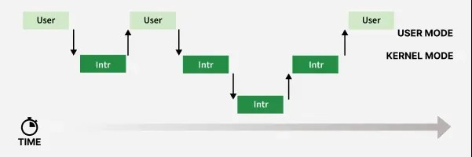

Control Paths

The following scenarios describe how kernel control paths are handled:

* **Exception Handling**: If the CPU detects an exception (for example, accessing a page not present in memory) while running a kernel control path, the current control path is suspended. The kernel then allocates a new page and loads its contents from disk. Once this procedure finishes, the original control path resumes, and the process continues as before.
* **Hardware Interrupts**: If a hardware interrupt occurs while the CPU is executing a kernel control path, the current control path is paused to process the interrupt. After the interrupt handler completes, the CPU returns to the original kernel control path. Both control paths are executed in the context of the same process, but the interrupt handler is not directly related to the process.
* **Kernel Preemption**: If kernel preemption is enabled and a higher priority process becomes runnable, the CPU will pause the current kernel control path and execute the control path of the higher priority process. This only happens if the kernel supports preemption, allowing more responsive task switching.

In all these cases, the kernel ensures efficient management of control paths, maintaining the smooth execution of processes while handling exceptions, interrupts, and scheduling tasks.

### Address Space in the Unix Kernel

While every user-space process has its own, isolated virtual address space, the Unix kernel also operates within its own, special address space. This is not just a conceptual view; it's the specific range of memory addresses that the kernel uses to access its own code, data, and manage the entire system's physical memory and hardware.

#### Key Characteristics of the Unix Kernel's Address Space:

1. **Single, Global Virtual Address Space:**
   * Unlike user processes, which each have their *own* distinct virtual address space, the Unix kernel typically operates within a **single, global virtual address space**. This means that all parts of the kernel (process management, memory management, file system, device drivers) share the same address mappings for kernel code and data.
   * This global nature allows kernel components to directly call functions and access data of other kernel components without complex context switching or inter-process communication overhead, contributing to the performance of monolithic and hybrid kernels.
2. **Partially Mapped into Every User Process's Address Space:**
   * A common and crucial design pattern in Unix-like systems (especially Linux on 64-bit architectures) is to **map the kernel's address space into the upper portion of *every* user process's virtual address space.**
   * For example, in a 64-bit system, the lower half of the virtual address space might be for user processes, and the upper half is reserved for the kernel.
   * **Why this is done:** This allows for very fast transitions between user mode and kernel mode during system calls. When a user process makes a system call, the CPU simply switches privilege levels (to kernel mode) without needing to change the entire set of memory page tables. The kernel's code and data are already "visible" (though protected from user-mode access) within the same virtual address space context.
   * **Protection:** This kernel region within a process's virtual address space is **strictly protected** by the Memory Management Unit (MMU). User-mode code cannot directly read from or write to these kernel addresses. Any attempt to do so results in a segmentation fault.
3. **Direct Mapping to Physical Memory (Often):**
   * A significant portion of the kernel's address space is often **directly mapped** to physical RAM. This means that a virtual address used by the kernel in this region corresponds directly to a physical RAM address (e.g., virtual address 0xC0000000 might map to physical address 0x00000000).
   * This direct mapping allows the kernel to efficiently access all of physical memory without needing complex page table lookups for its own operations, especially for managing physical memory itself.

#### Components within the Kernel's Address Space:

The kernel's address space contains:

* **Kernel Code (Text):** The executable instructions of the kernel itself.
* **Kernel Data:** Global and static variables used by the kernel.
* **Kernel Heap:** Dynamically allocated memory used by the kernel during its operation (e.g., for creating data structures for new processes, managing file buffers).
* **Per-Process Kernel Stacks:** While each user process has its own kernel stack, these stacks are typically allocated and managed within the kernel's address space.
* **Memory for Device Drivers:** The code and data for loadable kernel modules (device drivers) are loaded into this space.
* **Page Tables:** The kernel maintains and manages the page tables for both user processes and itself within its address space.
* **I/O Memory Mappings:** Regions for Memory-Mapped I/O (MMIO), allowing the kernel to directly communicate with hardware device registers.
* **Other Kernel Data Structures:** All internal kernel data structures (e.g., process lists, VFS caches, buffer caches) reside within this address space.

#### Purpose and Implications:

* **Privilege and Control:** The kernel's address space allows it to have complete control over all system resources and memory.
* **Efficiency:** The global nature and direct mappings enable very fast operations within the kernel without the overhead of address translation or context switching that user processes incur.
* **Security:** By being protected from user-mode access, the kernel's code and data cannot be directly tampered with by applications, ensuring system stability and integrity.
* **Unified View:** It provides the kernel with a consistent and comprehensive view of all physical memory and hardware, allowing it to manage them effectively.

In essence, the Unix kernel's address space is its private, privileged, and often globally mapped memory region where it houses all its operational components and directly controls the hardware, forming the bedrock of the entire operating system.

# Inter Process Communication (IPC)

Processes need to communicate with each other in many situations. **Inter-Process Communication or IPC** is a mechanism that allows processes to communicate. It helps processes synchronize their activities, share information, and avoid conflicts while accessing shared resources.

## Types of Process

Let us first talk about types of processes:

* **Independent process:**An **independent process** is not affected by the execution of other processes. Independent processes do not share any data or resources with other processes. No inter-process communication is required in this case.
* **Co-operating process:**Interact with each other and share data or resources. A co-operating process can be affected by other executing processes.Inter-process communication (IPC) is a mechanism that allows processes to communicate with each other and synchronize their actions. The communication between these processes can be seen as a method of cooperation between them.

## Inter Process Communication

Inter process communication (IPC) allows different processes running on a computer to share information with each other. IPC allows processes to communicate by using different techniques like sharing memory, sending messages or using files. It ensures that processes can work together without interfering with each other. [Cooperating processes](https://www.geeksforgeeks.org/cooperating-process-in-operating-system/)require an Inter Process Communication (IPC) mechanism that will allow them to exchange data and information.

The two fundamental models of Inter Process Communication are:

* Shared Memory
* Message Passing

An operating system can implement both methods of communication. First, we will discuss the shared memory methods of communication and then message passing. Communication between processes using shared memory requires processes to share some variable and it completely depends on how the programmer will implement it. Suppose process 1 and process 2 are executing simultaneously and they share some resources or use some information from another process. Process1 generates information about certain computations or resources being used and keeps it as a record in shared memory. When process 2 needs to use the shared information, it will check in the record stored in shared memory and take note of the information generated by process 1 and act accordingly. Processes can use shared memory for extracting information as a record from another process as well as for delivering any specific information to other processes.

Figure 1 below shows a basic structure of communication between processes via the shared memory method and via the message passing method.  
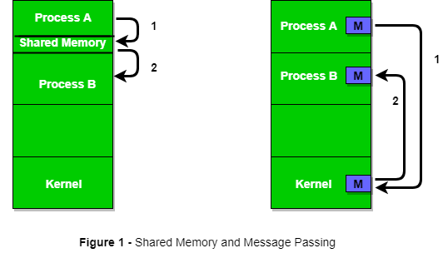

## ****Role of Synchronization in IPC****

### 1. ****Preventing Race Conditions****

In a multi-process environment, multiple processes may attempt to access shared data or resources at the same time. Without proper synchronization, this can lead to **race conditions**, where the outcome depends on the non-deterministic order in which processes access the resource. Synchronization mechanisms like **mutexes**, **semaphores**, and **locks** ensure that only one process can access a resource at a time, preventing inconsistent or corrupted data.

### 2. ****Ensuring Mutual Exclusion****

**Mutual exclusion (mutex)** is a fundamental concept in synchronization. It ensures that only one process at a time can access critical section. This prevents conflicts or inconsistent results when multiple processes attempt to modify shared data simultaneously.

### 3. ****Coordinating Process Execution****

It allows processes to wait for specific conditions to be met before proceeding. For example, one process may need to wait for data from another process before continuing. **Condition variables** and **barriers** are used in such cases to synchronize the execution order of processes.

### 4. ****Preventing Deadlocks****

Deadlocks occur when two or more processes are waiting indefinitely for resources held by each other. Proper synchronization techniques, such as acquiring resources in a defined order or using **deadlock detection** and **prevention mechanisms**can help avoid situations of deadlock.

### 5. ****Communication Between Processes****

In IPC, synchronization ensures that messages or data exchanged between processes are correctly received and processed. It coordinates the flow of data and ensures that a producer process doesn't overwrite data before a consumer process can use it or the consumer doesn't attempt to consume data that isn’t yet produced.

### 6. ****Fairness****

It ensures that all processes have an equal opportunity to access shared resources. This prevents starvation where some processes are indefinitely delayed while others continuously acquire resources. Techniques such as **round-robin scheduling** and **fair locks** can be used to ensure that no process is unfairly delayed.

## Methods in Inter process Communication

Inter-Process Communication refers to the techniques and methods that allow processes to exchange data and coordinate their activities. Since processes typically operate independently in a multitasking environment, IPC is necessary for them to communicate effectively without interfering with one another. There are several methods of IPC, each designed to suit different scenarios and requirements. These methods include shared memory, message passing, semaphores, and signals, etc.

*Read more about* [*methods of Inter Process Communication*](https://www.geeksforgeeks.org/methods-in-interprocess-communication/)*.*

## Advantages of IPC

* It enables processes to communicate with each other and share resources, leading to increased efficiency and flexibility.
* It facilitates coordination between multiple processes and leads to better overall system performance.
* It allows for the creation of distributed systems that can span multiple computers or networks.
* It can be used to implement various[synchronization](https://www.geeksforgeeks.org/introduction-of-process-synchronization/)and communication protocols, such as semaphores, pipes, and sockets.

## Disadvantages of IPC

* It increases system complexity, making it harder to design, implement, and debug.
* It can introduce security vulnerabilities, as processes may be able to access or modify data belonging to other processes.
* It requires careful management of system resources such as memory and[CPU](https://www.geeksforgeeks.org/difference-between-cpu-and-gpu/)time, to ensure that IPC operations do not degrade overall system performance.
* It can lead to data inconsistencies if multiple processes try to access or modify the same data at the same time.

#### Categories of IPC Mechanisms:

IPC mechanisms generally fall into two broad categories:

1. **Message Passing:** Processes communicate by sending and receiving messages.
2. **Shared Memory:** Processes communicate by reading and writing data to a shared region of memory.

#### Common IPC Mechanisms in Unix:

Unix-like systems offer a rich set of IPC mechanisms, each suited for different communication needs:

1. **Pipes:**
   * **Concept:** A basic, unidirectional (one-way) communication channel that allows data to flow from one process to another. It operates on a **First-In, First-Out (FIFO)** basis.
   * **Types:**
     + **Anonymous Pipes (| in shell, pipe() system call):** Used for communication between related processes (e.g., parent-child, siblings) as they are typically created by a common ancestor and inherited. They are temporary and unnamed.
       - *Example:* ls -l | grep "myfile" (output of ls is piped as input to grep).
     + **Named Pipes (FIFOs - mkfifo command, mkfifo() system call):** Have a name in the file system, allowing unrelated processes to communicate. They persist until explicitly deleted.
       - *Example:* One process writes to /tmp/my_fifo, another reads from it.
   * **Mechanism:** Kernel manages a buffer; one end is for writing, the other for reading.
2. **Message Queues:**
   * **Concept:** A list of messages stored within the kernel, each with a specific type. Processes can add messages to a queue (send) or retrieve messages from it (receive) based on type or order.
   * **Mechanism:** Kernel manages the queue; messages are copied between process address space and kernel space.
   * **Advantages:** More flexible than pipes as messages can be prioritized and retrieved non-sequentially based on type. Allows more complex message structures.
3. **Shared Memory:**
   * **Concept:** Allows multiple processes to attach to a common region of physical memory. Once attached, processes can read from and write to this shared region directly, as if it were their own memory.
   * **Mechanism:** Kernel sets up the shared segment, but data transfer happens directly between processes once mapped.
   * **Advantages:** This is the **fastest** form of IPC because data is not copied through the kernel; processes access it directly in RAM.
   * **Disadvantages:** Requires explicit **synchronization** mechanisms (like semaphores or mutexes) to prevent race conditions, as processes can simultaneously access the shared data.
4. **Semaphores:**
   * **Concept:** Not for data transfer, but primarily for **process synchronization** and **resource management**. A semaphore is an integer value, manipulated by wait (decrement) and signal (increment) operations, typically used to control access to shared resources (e.g., protecting a shared memory segment).
   * **Mechanism:** Kernel manages the semaphore's value and queues processes waiting on it.
   * **Types:** Binary semaphores (mutexes) for mutual exclusion, counting semaphores for resource counting.
5. **Sockets:**
   * **Concept:** A very flexible and powerful IPC mechanism that provides endpoints for communication. While most commonly associated with network communication (TCP/IP), Unix also supports **Unix Domain Sockets** for communication between processes on the *same machine*.
   * **Mechanism:** Can be stream-oriented (like TCP) or datagram-oriented (like UDP).
   * **Advantages:** Extremely versatile, allows for client-server models, and can easily extend to network communication. Unix Domain Sockets are often faster than network sockets for local IPC.
6. **Signals:**
   * **Concept:** A limited form of IPC used to notify a process about an event. Signals are asynchronous notifications (e.g., SIGTERM for termination, SIGKILL for forceful kill, SIGINT for interrupt).
   * **Mechanism:** Kernel sends a signal to a process, interrupting its normal flow. The process can catch (handle), ignore, or block signals (except SIGKILL and SIGSTOP).
   * **Note:** Signals are typically used for control flow or event notification, not for transferring large amounts of data.

**Process Synchronization** is used in a computer system to ensure that multiple processes or threads can run concurrently without interfering with each other.

The main objective of process synchronization is to ensure that multiple processes access shared resources without interfering with each other and to prevent the possibility of inconsistent data due to concurrent access. To achieve this, various synchronization techniques such as semaphores, monitors, and critical sections are used.

In a multi-process system, synchronization is necessary to ensure data consistency and integrity, and to avoid the risk of deadlocks and other synchronization problems. Process synchronization is an important aspect of modern operating systems, and it plays a crucial role in ensuring the correct and efficient functioning of multi-process systems.

On the basis of synchronization, [processes](https://www.geeksforgeeks.org/process-in-operating-system/) are categorized as one of the following two types:

* **Independent Process**: The execution of one process does not affect the execution of other processes.
* **Cooperative Process**: A process that can affect or be affected by other processes executing in the system.

Process synchronization problem arises in the case of Cooperative processes also because resources are shared in Cooperative processes.

## Process Synchronization

Process Synchronization is the coordination of execution of multiple processes in a multi-process system to ensure that they access shared resources in a controlled and predictable manner. It aims to resolve the problem of race conditions and other synchronization issues in a concurrent system.

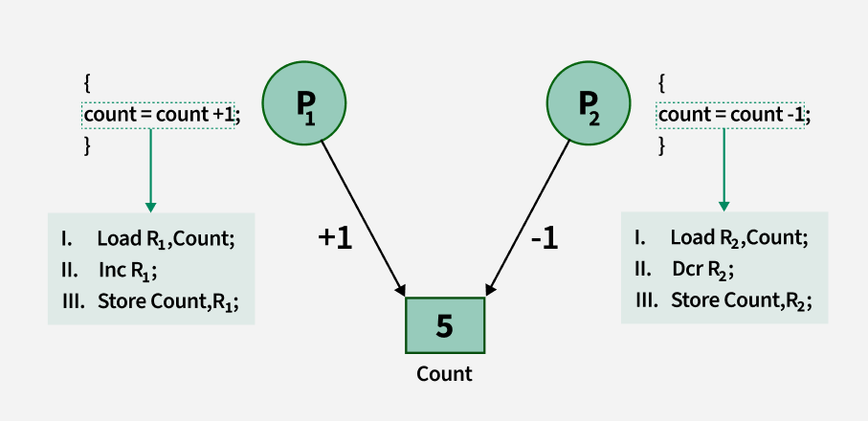

Lack of Synchronization in [Inter Process Communication](https://www.geeksforgeeks.org/inter-process-communication-ipc/)Environment leads to following problems:

1. **Inconsistency:**When two or more processes access shared data at the same time without proper synchronization. This can lead to conflicting changes, where one process’s update is overwritten by another, causing the data to become unreliable and incorrect.
2. **Loss of Data:**Loss of data occurs when multiple processes try to write or modify the same shared resource without coordination. If one process overwrites the data before another process finishes, important information can be lost, leading to incomplete or corrupted data.
3. **Deadlock:**Lack of Synchronization leads to [Deadlock](https://www.geeksforgeeks.org/introduction-of-deadlock-in-operating-system/)which means that two or more processes get stuck, each waiting for the other to release a resource. Because none of the processes can continue, the system becomes unresponsive and none of the processes can complete their tasks.

## Types of Process Synchronization

The two primary type of process Synchronization in an Operating System are:

1. **Competitive:**Two or more processes are said to be in Competitive Synchronization if and only if they compete for the accessibility of a shared resource.  
   **Lack of Synchronization among Competing process**may lead to either Inconsistency or Data loss.
2. **Cooperative:**Two or more processes are said to be in Cooperative Synchronization if and only if they get affected by each other i.e. execution of one process affects the other process.  
   **Lack of Synchronization among Cooperating process**may lead to Deadlock.

## Conditions That Require Process Synchronization

1. **Critical Section:**It is that part of the program where shared resources are accessed. Only one process can execute the critical section at a given point of time. If there are no shared resources, then no need of synchronization mechanisms.
2. **Race Condition:**It is a situation wherein processes are trying to access the critical section and the final result depends on the order in which they finish their update. Process Synchronization mechanism need to ensure that instructions are being executed in a required order only.
3. **Pre Emption:**Preemption is when the operating system stops a running process to give the CPU to another process. This allows the system to make sure that important tasks get enough CPU time. This is important as mainly issues arise when a process has not finished its job on shared resource and got preempted. The other process might end up reading an inconsistent value if process synchronization is not done.

## Classical IPC Problems

Various classical Inter-Process Communication (IPC) problems include:

* Producer Consumer Problem
* Readers-Writers Problem

**Process Synchronization** is the coordination of the execution of multiple processes to achieve a desired outcome, especially when these processes interact with shared resources or need to communicate. Its primary goal is to ensure data consistency and prevent race conditions when multiple processes (or threads within a process) access shared resources concurrently.

#### Why is Synchronization Necessary?

In a multitasking environment, multiple processes can run seemingly at the same time. If these processes operate on shared data or resources without proper coordination, several problems can arise:

1. **Race Condition:** This occurs when the outcome of the program depends on the unpredictable order or timing of operations by multiple processes accessing and modifying shared data. The final value of the shared data might be incorrect or inconsistent because the operations "race" to complete, and the final state depends on which process finishes its critical operations last.
   * *Example:* Two processes simultaneously try to increment a shared counter variable. If not synchronized, they might both read the same initial value, increment it independently, and then write back their results. Instead of the counter increasing by two, it might only increase by one.
2. **Inconsistent Data:** Without synchronization, one process might read partially updated or stale data written by another process, leading to logical errors or corrupt states.
3. **Deadlock:** A situation where two or more processes are permanently blocked, each waiting for a resource that is held by another process in the same cycle. Synchronization mechanisms themselves, if not implemented carefully, can contribute to deadlocks.
4. **Livelock:** A situation similar to deadlock, where processes continuously change their state in response to other processes, but no useful work is ever done.

#### Key Concepts in Synchronization:

1. **Critical Section:**
   * A segment of code in which a process accesses shared resources (shared variables, files, databases, hardware devices).
   * The fundamental requirement is that only **one process** should be allowed to execute its critical section at any given time to ensure data consistency. This is known as **mutual exclusion**.
2. **Mutual Exclusion:**
   * The guarantee that if one process is executing its critical section, no other process is allowed to execute its critical section involving the same shared resource.

#### Common Synchronization Mechanisms:

Operating systems and programming languages provide various mechanisms to achieve process synchronization:

1. **Semaphores:**
   * **Concept:** A synchronization primitive that is essentially an integer variable managed by the OS. It's accessed only through two atomic operations: wait() (or P or down()) and signal() (or V or up()).
   * **wait():** Decrements the semaphore value. If the value becomes negative, the process blocks until it becomes non-negative.
   * **signal():** Increments the semaphore value. If there are processes waiting, one is unblocked.
   * **Types:**
     + **Binary Semaphore (Mutex):** Initialized to 1. Used for mutual exclusion to protect a single critical section.
     + **Counting Semaphore:** Initialized to a positive integer (N). Used to control access to a resource with N instances.
   * **Usage:** Can be used to solve critical section problems, producer-consumer problems, etc.
2. **Mutexes (Mutual Exclusion Locks):**
   * **Concept:** A simpler, more specialized form of binary semaphore primarily used for **mutual exclusion**. A mutex can be acquired (locked) by only one process/thread at a time. If another tries to acquire it, it blocks until the mutex is released (unlocked).
   * **Common Usage:** Widely used to protect critical sections of code or shared data structures.
3. **Condition Variables:**
   * **Concept:** Used in conjunction with a mutex to allow processes/threads to wait for a specific condition to become true. A process releases the mutex and waits on a condition variable. Another process, after changing the state to make the condition true, signals the condition variable to wake up the waiting processes.
   * **Usage:** Ideal for scenarios where a process needs to wait for an event (e.g., a buffer becoming non-empty) rather than just a lock to be free.
4. **Monitors (Higher-Level Construct):**
   * **Concept:** A high-level language construct (not directly a primitive in Unix, but a conceptual model) that encapsulates shared data structures and the procedures that operate on them. It provides built-in mutual exclusion: only one process can be active within the monitor at any given time. Monitors often incorporate condition variables for complex waiting.
   * **Usage:** Simplifies synchronization code by bundling shared data with its access procedures and built-in locking.
5. **Readers-Writers Locks:**
   * **Concept:** A specialized lock that allows greater concurrency for data that is read more often than written. It allows multiple "reader" processes to access the shared resource concurrently, but only one "writer" process at a time. A writer gains exclusive access.
6. **Atomic Operations:**
   * **Concept:** Low-level hardware instructions that guarantee an operation (e.g., read-modify-write on a single memory location) completes entirely without interruption. These are the building blocks for higher-level synchronization primitives.

### Memory Management in Unix OS

**Memory management** in Unix refers to the operating system's comprehensive set of techniques and mechanisms for controlling and coordinating computer memory. Its primary goals are to:

1. **Allocate and Deallocate Memory:** Provide memory to processes and reclaim it when no longer needed.
2. **Protect Processes:** Isolate processes' memory spaces from each other and from the kernel to prevent interference and enhance system stability.
3. **Provide Abstraction:** Give each process the illusion of having a large, contiguous, private memory space, even if physical memory is fragmented or limited.
4. **Optimize Performance:** Efficiently use available RAM and disk space (swap) to maximize system throughput and responsiveness.

The central concept in Unix memory management is **Virtual Memory**.

#### 1. Virtual Memory: The Foundation

* **Concept:** Instead of processes directly accessing physical RAM addresses, they interact with **virtual addresses**. The Unix kernel, with hardware support from the **Memory Management Unit (MMU)**, translates these virtual addresses into actual physical addresses in RAM.
* **Benefits:**
  + **Process Isolation/Protection:** Each process gets its own distinct virtual address space, preventing one process from accidentally or maliciously accessing another's memory or the kernel's memory.
  + **Abstraction:** Programs don't need to know the physical layout of memory. They just use virtual addresses, simplifying programming.
  + **Memory Efficiency:** Allows programs larger than physical RAM to run, and enables efficient sharing of code and data.

#### 2. Paging: How Virtual Memory is Implemented

Unix systems primarily use **paging** to implement virtual memory:

* **Pages and Frames:** Both the virtual address space and the physical address space are divided into fixed-size blocks. Virtual memory is divided into **pages** (e.g., 4KB), and physical memory is divided into equally sized **frames** (or page frames).
* **Page Tables:** For each running process, the kernel maintains one or more **page tables**. These are data structures (often multi-level trees) that store the mapping from virtual page numbers to physical frame numbers. The MMU uses these tables during address translation.
* **Translation Lookaside Buffer (TLB):** A small, fast hardware cache within the CPU that stores recent virtual-to-physical address translations. This speeds up memory access by avoiding a full page table walk for every memory access.

#### 3. Swapping and Demand Paging: Handling Limited RAM

To provide the illusion of more memory than physically available, Unix uses:

* **Swap Space (Swap Partition/File):** A dedicated area on the hard disk that acts as an extension of RAM. When physical RAM becomes scarce, the kernel can move (swap out) less-used pages from RAM to swap space.
* **Demand Paging:** Pages are loaded into physical RAM only when they are actually referenced by a process (on "demand"). If a process tries to access a virtual address whose corresponding page is not in RAM (it might be on swap or hasn't been loaded yet), the MMU generates a **page fault**. The kernel then intercepts this fault, loads the required page from disk into a free physical frame, updates the page table, and restarts the instruction that caused the fault.

#### 4. Components of a Process's Virtual Address Space

Every user process in Unix sees its memory organized into distinct segments within its virtual address space:

* **Text (Code) Segment:** Contains the program's executable instructions. It's usually read-only and often shared among multiple instances of the same program.
* **Data Segment:** Contains initialized global and static variables.
* **BSS (Block Started by Symbol) Segment:** Contains uninitialized global and static variables, which are zero-initialized by the OS at runtime.
* **Heap:** Used for dynamic memory allocation (e.g., malloc(), new). It grows upwards towards higher addresses as memory is requested.
* **Stack:** Used for local variables, function arguments, and return addresses during function calls. It typically grows downwards (towards lower addresses).
* **Shared Libraries:** Dynamically loaded libraries (e.g., libc.so) are mapped into this space.
* **Kernel Space Mapping:** A portion of the virtual address space (typically the upper half in 64-bit systems) is reserved for mapping the kernel's own code and data. This allows for fast transitions during system calls, but this region is protected from user-mode access by the MMU.

#### 5. Kernel Memory Management:

The Unix kernel also needs to manage its own memory:

* **Kernel Heap:** The kernel has its own dynamic memory allocators (e.g., kmalloc, vmalloc in Linux) to manage memory for internal data structures (PCBs, inode caches, network buffers, etc.).
* **Buddy System/Slab Allocators:** These are common algorithms used by the kernel to efficiently manage physical memory frames and small object allocations.

#### 6. Shared Memory (IPC):

* Unix provides **shared memory** as an IPC mechanism. This allows different processes to map the *same physical memory frames* into their respective virtual address spaces. This enables very fast communication as data transfer occurs directly in RAM, bypassing the kernel once the mapping is set up.

Unix-like operating systems employ sophisticated memory management techniques to efficiently handle memory allocation and usage for running processes. These techniques include virtual memory, paging, and swapping, allowing for more processes to run concurrently and utilize more memory than physically available.

Here's a breakdown of key concepts:

1.Virtual Memory:

* Virtual memory allows processes to access more memory than physically available by utilizing disk space as an extension of RAM.
* It creates the illusion that each process has its own contiguous address space, even though the actual physical memory is shared.
* This is achieved by dividing memory into fixed-size blocks called pages and storing them on disk (swap space) when they are not actively being used.

2. Paging:

* Paging is the process of dividing both physical memory and virtual address spaces into fixed-size blocks (pages and frames, respectively).
* When a process needs a page that is not currently in physical memory (a page fault), the operating system retrieves it from disk and loads it into a free frame.
* This allows for non-contiguous memory allocation, meaning a process's pages can be scattered throughout physical memory.

3. Swapping:

* Swapping is a memory management technique where entire processes are moved between physical memory and disk (swap space).
* When memory is scarce, the operating system can swap out less active processes to disk, freeing up space for more frequently used ones.
* While swapping was common in older Unix systems, paging is the dominant technique in modern systems due to its greater flexibility.

4. Memory Allocation and Protection:

* Unix systems manage memory allocation by keeping track of used and free memory blocks, allocating memory to processes when requested, and deallocating it when no longer needed.
* Memory protection mechanisms prevent processes from accessing memory that is not allocated to them, enhancing system stability and security.

In essence, Unix memory management aims to:

**Maximize memory utilization:** Allowing more processes to run concurrently and utilize more memory than physically available.

**Optimize performance:** By minimizing the need to swap entire processes, and by using paging to load only the necessary parts of a process into memory.

**Ensure system stability:** By protecting processes from interfering with each other's memory spaces.

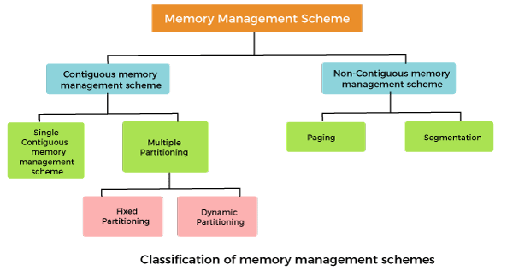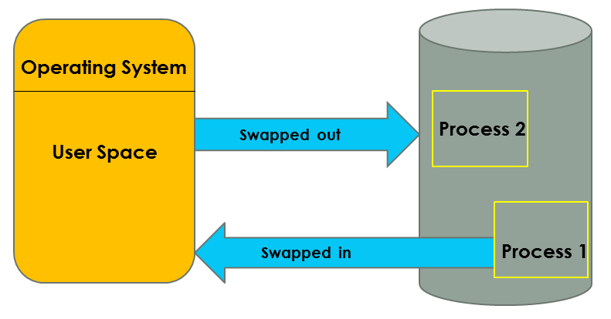

### Page Map TablePaging Device Drivers in Unix OS

In the Unix operating system, a **device driver** is a specific piece of software that allows the operating system kernel and user applications to interact with a particular hardware device (like a hard disk, network card, keyboard, mouse, printer, USB device, etc.).

#### 1. Purpose of Device Drivers:

The primary purposes of device drivers are:

* **Abstraction and Simplification:** To abstract away the complexities and idiosyncrasies of specific hardware devices. The kernel and applications don't need to know the intricate details of how to control a particular disk controller or network chip. They simply make standard requests (e.g., "read data," "send packet"), and the driver translates those requests into hardware-specific commands.
* **Hardware Independence:** By providing a standard interface to the kernel, drivers enable the operating system to support a wide range of hardware without needing to modify the core kernel code for every new device.
* **Encapsulation of Device-Specific Logic:** All the unique logic required to initialize, configure, and operate a specific piece of hardware is encapsulated within its driver.
* **Resource Management:** Drivers play a role in managing hardware resources, handling interrupts, and reporting device status.

#### 2. How Device Drivers Work (Mechanism):

1. **Kernel Component:** Device drivers are typically part of the Unix kernel. In modern Unix-like systems (like Linux), most drivers are implemented as **Loadable Kernel Modules (LKMs)**. This means they can be dynamically loaded into and unloaded from the running kernel without requiring a system reboot, making the kernel more flexible and reducing its memory footprint.
2. **Standard Interface to Kernel:** Drivers expose a standard set of functions (e.g., open, close, read, write, ioctl) that the kernel can call to interact with the device. When a user application makes a system call related to a device (e.g., read() from /dev/sda1), the kernel routes that request to the appropriate driver's function.
3. **Hardware Interaction:** Inside the driver, these functions translate the kernel's high-level requests into low-level hardware commands. This often involves:
   * **Writing to/Reading from Device Registers:** Drivers directly manipulate specific memory-mapped I/O (MMIO) or port-mapped I/O (PMIO) registers on the device controller.
   * **Handling Interrupts:** Devices often signal completion or error conditions by generating **interrupts**. Drivers contain **Interrupt Service Routines (ISRs)** or **Interrupt Handlers** that are executed by the kernel when a device's interrupt occurs. These handlers acknowledge the interrupt, process the event, and potentially wake up processes waiting for the I/O to complete.
   * **Direct Memory Access (DMA):** For high-speed devices (like disk controllers, network cards), drivers often configure **Direct Memory Access (DMA)** controllers. DMA allows the device to transfer data directly to and from system memory without involving the CPU, freeing the CPU for other tasks.

#### 3. Unix's "Everything is a File" Philosophy and Device Files:

A core tenet of Unix is that "everything is a file." Hardware devices are no exception. Device drivers present the hardware to the Unix file system as special files located typically in the /dev directory.

* **Block Device Files (b in ls -l):** Used for devices that transfer data in fixed-size blocks, like hard drives (/dev/sda), SSDs, or CD-ROMs. Operations on these devices typically involve buffering and block-aligned access.
  + *Example:* Reading a specific sector from a disk.
* **Character Device Files (c in ls -l):** Used for devices that transfer data one character (byte) at a time, without buffering, or where data streams continuously. Examples include serial ports (/dev/ttyS0), keyboards (/dev/input/event0), or printers (/dev/lp0).
  + *Example:* Reading a key press from the keyboard.

When an application opens /dev/sda1 or /dev/tty, it's not opening a regular file; it's instructing the kernel to use the associated device driver to interact with the underlying hardware.

#### 4. Key Responsibilities of a Device Driver:

* **Initialization:** At system boot or when the driver is loaded, it initializes the hardware device, checks its status, and allocates necessary resources.
* **I/O Request Handling:** Implements open(), close(), read(), write(), and ioctl() (input/output control) functions that translate user/kernel requests into hardware commands.
* **Interrupt Handling:** Provides Interrupt Service Routines (ISRs) to respond to hardware interrupts, process the event (e.g., data ready, error), and signal completion.
* **Error Handling:** Manages hardware-specific error conditions.
* **Power Management:** (In modern systems) May include logic for power saving modes.
* **Resource Management:** Allocates and frees hardware-related resources like DMA buffers, I/O ports, and interrupt lines.

In essence, device drivers are crucial, low-level software components that extend the Unix kernel's capabilities, allowing it to seamlessly manage and provide access to a vast array of hardware devices, while maintaining the OS's abstraction and security principles

# CPU Scheduling in Operating Systems

**CPU scheduling** is a process used by the operating system to decide which task or process gets to use the CPU at a particular time. This is important because a CPU can only handle one task at a time, but there are usually many tasks that need to be processed. The following are different purposes of a CPU scheduling time.

* Maximize the CPU utilization
* Minimize the response and waiting time of the process.

## What is the Need for a CPU Scheduling Algorithm?

**CPU scheduling** is the process of deciding which process will own the CPU to use while another process is suspended. The main function of CPU scheduling is to ensure that whenever the CPU remains idle, the OS has at least selected one of the processes available in the ready-to-use line.

In Multiprogramming, if the long-term scheduler selects multiple I/O binding processes then most of the time, the CPU remains idle. The function of an effective program is to improve resource utilization.

## Terminologies Used in CPU Scheduling

* **Arrival Time:** The time at which the process arrives in the ready queue.
* **Completion Time:** The time at which the process completes its execution.
* **Burst Time:** Time required by a process for CPU execution.
* **Turn Around Time:** Time Difference between completion time and arrival time.

*Turn Around Time = Completion Time  –  Arrival Time*

* **Waiting Time(W.T):** Time Difference between turn around time and burst time.

*Waiting Time = Turn Around Time  –  Burst Time*

## Things to Take Care While Designing a CPU Scheduling Algorithm

Different **CPU Scheduling algorithms**have different structures and the choice of a particular algorithm depends on a variety of factors.

* **CPU Utilization:**The main purpose of any CPU algorithm is to keep the CPU as busy as possible. Theoretically, CPU usage can range from 0 to 100 but in a real-time system, it varies from 40 to 90 percent depending on the system load.
* **Throughput:**The average CPU performance is the number of processes performed and completed during each unit. This is called throughput. The output may vary depending on the length or duration of the processes.
* **Turn Round Time:**For a particular process, the important conditions are how long it takes to perform that process. The time elapsed from the time of process delivery to the time of completion is known as the conversion time. Conversion time is the amount of time spent waiting for memory access, waiting in line, using CPU and waiting for I/O.
* **Waiting Time:**The Scheduling algorithm does not affect the time required to complete the process once it has started performing. It only affects the waiting time of the process i.e. the time spent in the waiting process in the ready queue.
* **Response Time:**In a collaborative system, turn around time is not the best option. The process may produce something early and continue to computing the new results while the previous results are released to the user. Therefore another method is the time taken in the submission of the application process until the first response is issued. This measure is called response time.

## Different Types of CPU Scheduling Algorithms

There are mainly two types of scheduling methods:

* **Preemptive Scheduling:**Preemptive scheduling is used when a process switches from running state to ready state or from the waiting state to the ready state.
* **Non-Preemptive Scheduling:**Non-Preemptive scheduling is used when a process terminates , or when a process switches from running state to waiting state.

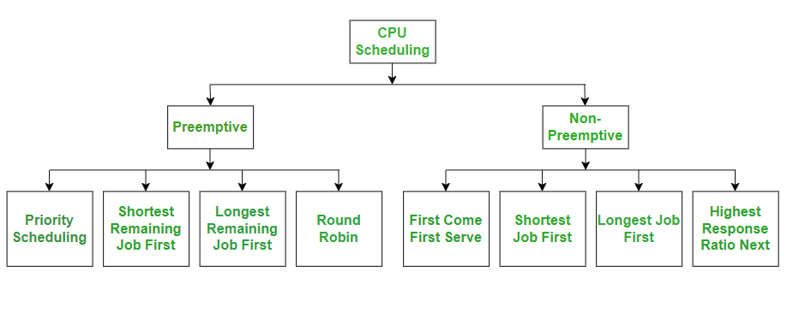CPU Scheduling

Please refer [Preemptive vs Non-Preemptive Scheduling](https://www.geeksforgeeks.org/preemptive-and-non-preemptive-scheduling/)for details.

## CPU Scheduling Algorithms

Let us now learn about these CPU scheduling algorithms in operating systems one by one:

* [FCFS - First Come, First Serve](https://www.geeksforgeeks.org/first-come-first-serve-cpu-scheduling-non-preemptive/)
* [SJF - Shortest Job First](https://www.geeksforgeeks.org/shortest-job-first-or-sjf-cpu-scheduling/)
* [SRTF - Shortest Remaining Time First](https://www.geeksforgeeks.org/shortest-remaining-time-first-preemptive-sjf-scheduling-algorithm/)
* [Round Robin](https://www.geeksforgeeks.org/round-robin-scheduling-in-operating-system/)
* [Priority Scheduling](https://www.geeksforgeeks.org/priority-scheduling-in-operating-system/)
* [HRRN - Highest Response Ratio Next](https://www.geeksforgeeks.org/highest-response-ratio-next-hrrn-cpu-scheduling/)
* [Multiple Queue Scheduling](https://www.geeksforgeeks.org/multilevel-feedback-queue-scheduling-mlfq-cpu-scheduling/)
* [Multilevel Feedback Queue Scheduling](https://www.geeksforgeeks.org/multilevel-feedback-queue-scheduling-mlfq-cpu-scheduling/)

**Chapter 2**

You're right, diagrams are incredibly helpful for visualizing these concepts! While I can't directly *draw* images here, I can describe them conceptually, guiding you on what each diagram would illustrate and what elements to include.

Imagine these as simple block diagrams:

**1. Conceptual Diagram: The Process (Heavyweight Process)**

This diagram highlights the isolation and complete resource ownership of a process. 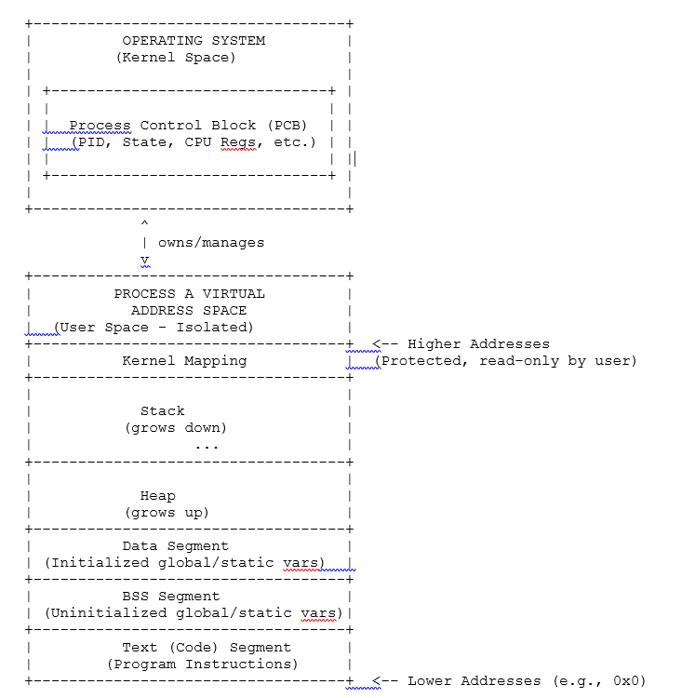

**Explanation of Diagram 1 (Process):**

* **Isolation:** Notice the clear boundary. Process A has its own distinct virtual address space. No other user process can directly read from or write to its memory unless explicitly allowed (e.g., via shared memory IPC).
* **Kernel Role:** The Operating System (kernel) owns and manages the **Process Control Block (PCB)**, which is the complete blueprint of Process A.
* **Resource Ownership:** The diagram shows the process "owning" its entire address space, including its code, data, heap, and a primary stack.

### 2. Conceptual Diagram: Threads (within a Process) / Kernel Threads

This diagram shows multiple threads residing *within* a single process, sharing many resources while having their own execution contexts.

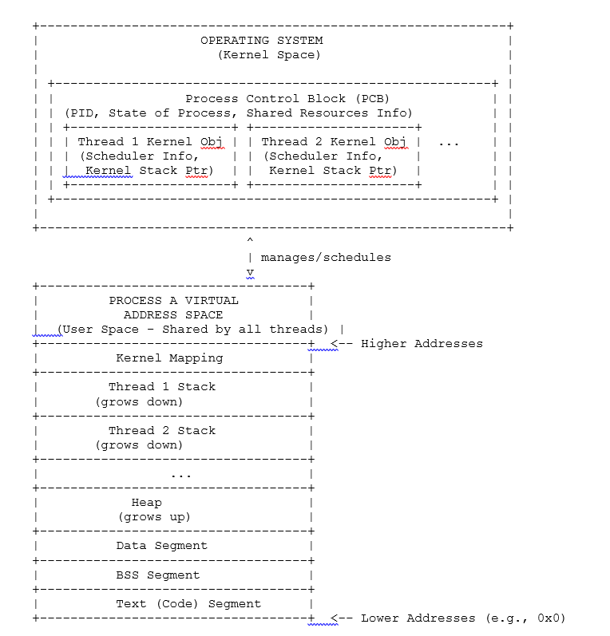

**Explanation of Diagram 2 (Threads / Kernel Threads):**

* **Shared Address Space:** All threads (Thread 1, Thread 2, etc.) exist within the *same* Process A's virtual address space. This means they share the code, data, heap, and open files of Process A.
* **Individual Execution Contexts:** Each thread has its own private **stack**, its own **Program Counter (PC)** (not explicitly drawn as a box, but conceptually present with CPU registers), and its own set of **CPU Registers**.
* **Kernel Management:** The kernel (via the Process Control Block for the process, and potentially specific thread objects/descriptors within it) is aware of each individual thread. It manages and schedules each thread for execution on a CPU core. This is why they are called "Kernel Threads" or are the underlying "Lightweight Processes" that the kernel schedules.
* **Lighter Context Switch:** When the OS switches between Thread 1 and Thread 2 (within the same process), it doesn't need to change the MMU's page table mappings for the entire address space, only the PC and registers of the specific thread, making it much faster than a process switch.

A thread is a single, sequential flow of execution within a process. Processes can have multiple threads, allowing them to perform multiple tasks concurrently. Threads share the process's resources like memory and open files, but each thread has its own program counter, stack, and registers.

Key Differences between Threads and Processes:

* Concurrency:
  + Threads allow for true parallelism within a single process, while processes are generally independent and have their own memory space.
* Resource Sharing:
  + Threads share resources like memory and open files, making communication between threads faster and easier than between processes.
* Creation and Context Switching:
  + Creating and switching between threads is faster and less resource-intensive than creating and switching between processes.
* Independence:
  + Processes are more independent than threads, meaning a problem with one process typically doesn't affect others.

In essence, threads are like lightweight processes, offering a way to achieve concurrency within a single program, while processes are more heavyweight and independent units of execution.

**A Lightweight Process (LWP)** is a means of achieving multitasking within an operating system, often used in the context of multithreaded programming. LWPs act as a bridge between user-level threads and the kernel's scheduling mechanisms, allowing multiple user threads to run concurrently on a smaller number of kernel-level threads.

**Traditional Threading:** In some older systems, user-level threads were directly mapped to kernel threads, meaning each user thread required a dedicated kernel thread. This could be inefficient, especially when dealing with a large number of threads.

**Lightweight Processes:** LWPs introduce a layer of abstraction. They are essentially virtual processors created and managed by the kernel. User-level threads are then multiplexed onto these LWPs.

How LWPs Work:

**User-Level Threads:** These are the threads that your application code creates and manages using a threading library.

**Lightweight Processes (LWPs):** These are kernel-level entities that act as virtual processors.

**Mapping:** The threading library maps multiple user-level threads onto a smaller or equal number of LWPs.

**Scheduling:** The operating system schedules the LWPs to run on the available CPU cores.

**User-Kernel Interaction:** LWPs facilitate communication between user-level threads and the kernel.

**Benefits of LWPs:**

**Shared Process Resources:** All LWPs (and the user threads they back) share the single virtual address space and other resources (file descriptors, signal handlers) of the parent process.

**Improved Efficiency:**

Multiplexing user threads onto LWPs can reduce the overhead associated with creating and managing kernel threads, especially when dealing with a large number of concurrent thread s.

**Concurrency:**

LWPs allow for true concurrency, meaning multiple user threads can execute simultaneously, potentially improving application performance.

**Blocking System Calls:**

If a user thread makes a blocking system call, it can be blocked without affecting other threads mapped to the same LWP. The kernel can then schedule another user thread onto that LWP.

LWPs in Linux:

* In Linux, the clone() system call is used to create LWPs.
* LWPs are essentially kernel tasks that share resources (like memory) with other threads within the same process.
* A process can have multiple LWPs, and each LWP can have one or more user-level threads associated with it.
* In essence, LWPs provide a more efficient and flexible way to manage concurrency in multithreaded applications by allowing multiple user-level threads to share a smaller number of kernel-level resources.

### Conceptual Diagram: The Process Descriptor (PCB / task_struct)

This diagram shows the internal structure of a Process Descriptor, which resides in the Operating System's Kernel Space.

**Explanation of the Diagram:**

* **Central Role:** The large outer box represents the **Operating System Kernel's Memory**, where all kernel data structures reside. The **Process Descriptor (PCB)** is the centerpiece within this.
* **Uniqueness:** Each process in the system has its own distinct PCB. The kernel maintains a list or tree of all these PCBs.
* **Categorized Information:** I've divided the PCB into logically grouped sections, each containing crucial details about the process:
  + **Identification:** Who the process is (PID, UID), and its place in the process hierarchy (PPID, PGID, SID).
  + **State:** The current execution status of the process (Running, Sleeping, etc.). This is dynamic.
  + **CPU State (Context):** The essential data the CPU needs to resume executing this process. This includes the Program Counter (where to execute next) and the values in all CPU registers. This is saved/restored during context switches.
  + **Scheduling:** Information the OS scheduler uses to decide when and for how long the process gets the CPU.
  + **Memory Management:** Pointers to the process's **Page Tables** (external to the PCB, but vital for its address space) and descriptions of its virtual memory regions (VMAs for code, data, heap, stack).
  + **File Management:** A pointer to the process's **File Descriptor Table** (which lists all files and devices it has open) and information about its current directory.
  + **Signal Handling:** How the process responds to events (signals), which signals it's blocking, and if it has pending signals.
  + **IPC Information:** Any inter-process communication objects it's involved with.
  + **Accounting:** Resource usage statistics for monitoring and billing.
  + **Linkage Pointers:** Pointers that connect this PCB to others, forming lists (e.g., the global list of all processes, or children linked to their parent).

**How the Kernel Uses It:**

When the kernel needs to perform any operation related to a process – whether it's scheduling it, allocating memory, handling a file I/O request, or delivering a signal – it refers to that process's descriptor to get the necessary information. It's the central hub of all process-specific data.

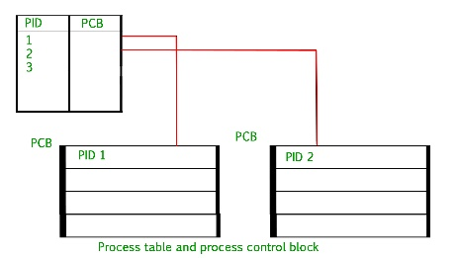

### Process Descriptor (PCB)This diagram shows the core, fundamental information the kernel stores for each process.

**Explanation of the Simplified Diagram:**

This simplified PCB highlights the core data a kernel *must* track for every process:

1. **Process Identification (PID):** The unique number that identifies the process. Without this, the kernel cannot distinguish one process from another.
2. **Process State:** Indicates what the process is currently doing (e.g., actively running, waiting for an event, or finished). This tells the scheduler if the process can be run.
3. **CPU Context (Program Counter & CPU Registers):** These collectively represent the exact point of execution the process was at when it last stopped. They are crucial for the kernel to save and restore when switching between processes, allowing a process to resume exactly where it left off.
4. **Memory Management Info (Pointer to Page Table):** This is the direct link to the process's **virtual address space**. The page table defines how the process's virtual memory maps to physical RAM. Without this, the kernel wouldn't know where the process's code and data are loaded.
5. **File Management Info (Pointer to File Descriptor Table):** This points to the list of all files and devices the process currently has open. This is how the kernel knows what resources the process is actively using for I/O.
6. **Scheduling/Linkage (Implicit):** While not detailed, the PCB inherently contains pointers that allow the kernel to link it into various queues (like the run queue or wait queues), enabling the scheduler to manage the flow of processes.

These attributes form the absolute minimum set necessary for the operating system kernel to control, schedule, and ensure the proper execution of a process.

### Identifying a Process (Simplified)

Imagine every program running on your computer is like a person in a big city. The operating system (Unix) needs a way to tell them apart, know who they are, who created them, and what they're allowed to do.

This is done using a few key ID numbers:

1. **Process ID (PID):**
   * **What it is:** This is the most important one. It's a **unique number** that the operating system gives to every single program instance when it starts running. Think of it like a person's unique **Passport Number** or **Social Security Number**.
   * **Why it's important:** The OS uses this PID to find all the information about that specific running program (its memory, what it's doing). You use it to tell the OS to do something to that specific program, like "stop program number 1234" (kill 1234).
   * **Example:** When you open a web browser, it gets a PID. If you open another browser window, it might be a new process with a different PID.

**Special PIDs:**

**PID 0:** Typically reserved for the swapper or scheduler process (the ancestor of all kernel threads). It's a special kernel process.

**PID 1:** Traditionally assigned to the init process (or systemd in modern Linux distributions). This process is the "grandparent" of all user-space processes. It's responsible for managing orphaned processes (children whose parents died) and acting as the primary process manager for the system.

* + **Parent Process ID (PPID):**
  + **What it is:** Every program, except the very first one that starts when the computer boots up (called init or systemd), is started by another program. The PPID tells you **which program started *this* program**. It's like knowing your **parent's ID**.
  + **Why it's important:** This creates a family tree of programs. The OS uses it to keep track of relationships, especially for cleanup when programs finish.

1. **User ID (UID) and Effective User ID (EUID):**
   * **What they are:** These numbers tell the operating system **who owns the program** and what permissions it has.
     + **UID:** The ID of the user who originally launched the program.
     + **EUID:** The ID that the program is currently using for its permissions. Usually, UID and EUID are the same. But sometimes, a special program might temporarily run with the permissions of another user (like root) to do a specific job (e.g., changing your password).
   * **Why they're important:** This is for security. It prevents one user's program from messing with another user's files or system settings.

**In short:**

* **PID:** The unique name tag for *this* running program.
* **PPID:** The ID of the program that *started* this program.
* **UID/EUID:** The ID of the *user* who owns this program and controls its permissions.

You can often see these IDs using simple commands like ps or top in your Unix terminal.

#### How to View Process Identifiers (Common Unix Commands):

* **ps:** Displays information about active processes.
  + ps aux: Shows all processes.
  + ps -ef: Shows full listing.
  + ps -ejH: Shows PID, PPID, PGID, and hierarchy.
* **top / htop:** Real-time display of running processes and their IDs.
* **pstree:** Displays processes in a tree format, showing the parent-child relationships clearly.
* **getpid() / getppid() / getuid() / getgid():** System calls used by programs to retrieve their own IDs.

Instead of just being a flat list, processes form structured relationships that the kernel uses for job control, resource management, and proper cleanup.

There are three primary types of **relationships** among processes in Unix:

1. **Parent-Child Relationship (Process Hierarchy)**
2. **Process Groups**
3. **Sessions**

### 1. Parent-Child Relationship (Process Hierarchy)

This is the most fundamental relationship.

* **How it's Formed:** Every process (except the very first one) is created by another process using the fork() system call. The process that calls fork() is the **parent process**, and the newly created process is the **child process**.
* **Process IDs (PIDs & PPIDs):**
  + Each child process gets its own unique **Process ID (PID)**.
  + The child process also stores the **Parent Process ID (PPID)**, which is the PID of its parent.
* **The Process Tree:** This creates a hierarchical "tree" structure of processes.
  + The init process (PID 1) or systemd (in modern Linux) is the ultimate ancestor of all user-space processes. It's the first process started by the kernel during boot, and its PPID is 0. All other processes are descendants of init.
  + You can visualize this hierarchy using the pstree command in a Unix terminal.
* **Inheritance:** When a child process is created via fork(), it inherits many attributes from its parent, such as:
  + A copy of the parent's memory space (often using copy-on-write).
  + Open file descriptors.
  + Current working directory.
  + User and Group IDs.
  + Signal handlers.
* **Orphan Processes:** If a parent process terminates *before* its child processes, the orphaned children are automatically "re-parented" to the init (or systemd) process. init then becomes their new parent and takes responsibility for collecting their exit status when they eventually terminate.
* **Zombie Processes:** When a child process terminates, its resources are largely freed, but its Process Control Block (PCB) remains in a ZOMBIE state until its parent calls wait() or waitpid() to collect its exit status. This ensures the parent can know how its child finished. If the parent doesn't wait(), the zombie persists until the parent dies (and init eventually cleans it up).

**Example:**

bash (PID 100) <-- Parent Process

|

+-- firefox (PID 200) <-- Child of bash

| |

| +-- firefox_renderer (PID 201) <-- Child of firefox

|

+-- ls (PID 101) <-- Child of bash

### 2. Process Groups

A **process group** is a collection of one or more related processes, typically created for job control purposes, especially in shell environments.

* **How it's Formed:**
  + When a process is fork()ed, the child usually inherits its parent's process group ID (PGID).
  + Shell pipelines (cmd1 | cmd2 | cmd3) automatically place all commands in the pipeline into a single process group.
  + A process can explicitly join or create a new process group using setpgid() system call.
* **Process Group ID (PGID):** Each process group has a unique **Process Group ID (PGID)**. The PGID is typically the PID of the **process group leader** (the first process in the group).
* **Purpose (Job Control):**
  + **Signal Delivery:** Allows signals to be sent to an entire group of processes simultaneously (e.g., kill -TERM -PGID will terminate all processes in that group). This is essential for shell job control (e.g., Ctrl+C sends SIGINT to the foreground process group).
  + **Foreground/Background:** In a terminal session, only the processes in the **foreground process group** can receive input from the terminal and are affected by terminal control signals (Ctrl+C, Ctrl+Z). Background process groups are typically ignored by the terminal.

**Example:** If you type grep "error" log.txt | sort > sorted_errors.txt in your shell, grep, sort, and the shell's process to redirect output will likely be in the same process group.

### 3. Sessions

A **session** is a collection of one or more process groups, typically associated with a login shell or a terminal.

* **How it's Formed:**
  + A new session is typically created when a user logs in and their login shell starts. The login shell usually becomes the **session leader**.
  + A process can create a new session using the setsid() system call (often done by daemon processes to detach from their controlling terminal).
* **Session ID (SID):** Each session has a unique **Session ID (SID)**, which is usually the PID of the session leader.
* **Purpose (Terminal Control & Lifecycle):**
  + **Controlling Terminal:** A session can have a **controlling terminal**. Processes in the foreground process group of that session receive input from this terminal.
  + **Login Lifecycle:** When a user logs out, the session leader (the login shell) terminates, and the kernel typically sends signals (e.g., SIGHUP) to all process groups within that session, leading to their termination. This ensures processes associated with a user's session are cleaned up when the user logs out.
  + **Daemons:** Server processes (daemons) often detach from any controlling terminal by creating a new session, ensuring they aren't terminated when a user logs out.

**Example:** Your interactive bash shell is typically a session leader. Any commands you run in that shell, and any pipelines you create, will belong to that shell's session.

**Organization**

The **Organization of Processes** in a Unix-like operating system refers to how the kernel internally structures and manages all the running programs (processes) to ensure efficient scheduling, resource allocation, and overall system stability. It's about the data structures and algorithms the kernel uses to keep track of, find, and manipulate thousands of processes concurrently.

Here's a breakdown of the key organizational principles:

1. **Process Control Blocks (PCBs): The Central Record:**
   * At the heart of process organization is the **Process Control Block (PCB)**, often called task_struct in Linux.
   * **Every single process** has its own unique PCB. This is a dedicated data structure in the kernel's memory that stores all relevant information about that process: its current state, PID, PPID, CPU registers, memory details (e.g., pointer to its page tables), open files, scheduling priority, and more.
   * The kernel uses the PCB as the definitive source of truth for everything related to a specific process.
2. **Global Process List (Doubly Linked List):**
   * To keep track of *all* active PCBs, the kernel typically links them together into a **doubly linked list**.
   * Each PCB contains pointers (e.g., next_task and prev_task in Linux) that connect it to the preceding and succeeding PCBs in this global list.
   * **Purpose:** This allows the kernel to quickly iterate through all existing processes (e.g., when you run the ps command) and ensures that no process is lost.
3. **Process Tree (Parent-Child Hierarchy):**
   * Processes are not just a flat list; they form a **hierarchy** based on parent-child relationships established by the fork() system call.
   * Each PCB contains pointers to:
     + Its **parent's PCB**.
     + A list of its **children's PCBs**.
     + Its **sibling's PCBs** (other children of the same parent).
   * **The init (or systemd) process (PID 1)** is at the root of this tree, the ultimate ancestor of all user-space processes.
   * **Purpose:** This hierarchy is crucial for managing process groups, sessions, handling orphaned processes (re-parenting to init), and supporting functions where parents wait for children (wait() system call).
4. **Scheduling Queues (Run and Wait Queues):**
   * To manage the CPU and ensure fair access, the kernel organizes processes based on their execution state:
     + **Run Queues (or Ready Queues):** These are lists of PCBs for processes that are in the "Ready" state – meaning they are ready to run and just waiting for the CPU to become available. The scheduler picks processes from these queues. In multi-core systems, there might be separate run queues for each CPU core.
     + **Wait Queues (or Blocked Queues):** These are lists of PCBs for processes that are in the "Waiting" (or "Blocked") state. Processes are placed on specific wait queues associated with the event they are waiting for (e.g., waiting for I/O completion, waiting for a resource to be freed, waiting for a signal). When the event occurs, the process's PCB is moved from the wait queue back to a run queue.
   * **Purpose:** These queues enable the scheduler to efficiently manage CPU allocation and ensure processes only consume CPU when they are actually able to make progress.
5. **Resource-Specific Data Structures (Linked from PCB):**
   * While the PCB holds pointers, the actual management of specific resources is often handled by other dedicated kernel structures, which are then referenced by the PCB:
     + **Memory Management:** The PCB points to the process's **Page Tables**, which map its virtual memory addresses to physical RAM. It also often points to lists of **Virtual Memory Areas (VMAs)** that describe different regions of its address space.
     + **File Management:** The PCB points to the process's **File Descriptor Table**, which lists all files and I/O devices currently open by that process. This table, in turn, points to system-wide structures representing open files.
   * **Purpose:** This modular approach allows for flexible and efficient management of various resources.

In essence, the kernel's process organization relies on a sophisticated network of interconnected PCBs, linked together in lists, trees, and queues, along with pointers to resource-specific tables. This structure allows the operating system to precisely track, control, and schedule every process in the system.

### Resource Limits: How the OS Sets Boundaries on Process Resource Usage

**Resource Limits** (often referred to as rlimits in Unix-like systems) are mechanisms provided by the operating system kernel to control the amount of system resources that a process or a group of processes can consume. These limits are set on a per-process basis and are crucial for:

1. **System Stability:** Preventing a single runaway or malicious process from consuming all available CPU, memory, or file descriptors, which could lead to a system crash or denial-of-service for other users/applications.
2. **Fairness:** Ensuring that no single process monopolizes shared system resources, allowing for more equitable distribution among competing processes.
3. **Security:** Limiting the potential damage an exploited process could inflict.
4. **Debugging:** Helping developers identify processes that consume excessive resources.

**How the OS Implements Resource Limits:**

* **Per-Process Storage:** For each process, its current resource limits are stored in its **Process Control Block (PCB)**.
* **Kernel Enforcement:** The operating system kernel is responsible for enforcing these limits. Whenever a process attempts to allocate a resource (e.g., request more memory, open a new file, create a child process), the kernel checks if the request would exceed any of the process's defined limits.
* **Actions on Exceeding Limits:** If a limit is exceeded, the kernel can take various actions:
  + Deny the resource request (e.g., a malloc() call fails).
  + Send a signal to the process (e.g., SIGXCPU for CPU time limits, SIGSEGV for memory limits).
  + Terminate the process.

**Commonly Limited Resources:**

Here are some of the most common resources for which limits are typically set:

1. **CPU Time (RLIMIT_CPU):**
   * **Description:** Limits the total amount of CPU time (in seconds) that a process can consume.
   * **Action on Exceeding:** When a process exceeds its CPU time limit, the kernel typically sends it a SIGXCPU signal. If the process does not catch or handle this signal, it usually terminates.
   * **Purpose:** Prevents infinite loops or runaway computations from monopolizing the CPU.
2. **Memory Limits:**
   * **Virtual Memory Size (RLIMIT_AS or RLIMIT_VMEM):**
     + **Description:** Limits the total size of the process's virtual address space (including code, data, stack, heap). This determines how much memory the process *can request*.
     + **Action on Exceeding:** Attempts to malloc() or mmap() beyond this limit will fail.
   * **Resident Set Size (RSS) / Physical Memory:**
     + **Description:** While not always a strict hard limit enforced with a signal (it's more of a tunable), the kernel's memory management unit tries to keep the amount of *physical* memory a process occupies within reasonable bounds, often by swapping out pages if a system-wide limit is approached.
   * **Stack Size (RLIMIT_STACK):**
     + **Description:** Limits the maximum size of the process's stack.
     + **Action on Exceeding:** Stack overflow (e.g., due to deep recursion) will typically lead to a SIGSEGV signal, terminating the process.
3. **File Descriptors (RLIMIT_NOFILE):**
   * **Description:** Limits the maximum number of file descriptors that a single process can have open concurrently. File descriptors represent open files, sockets, pipes, and other I/O resources.
   * **Action on Exceeding:** Subsequent open(), socket(), or pipe() system calls will fail with an "Too many open files" error (EMFILE).
   * **Purpose:** Prevents a process from exhausting the system's file descriptor table, which is a finite resource.
4. **Number of Processes (RLIMIT_NPROC):**
   * **Description:** Limits the maximum number of child processes that a single user (or more precisely, a single process) can create.
   * **Action on Exceeding:** Subsequent fork() or clone() system calls will fail with an "Resource temporarily unavailable" error (EAGAIN).
   * **Purpose:** Prevents fork bombs or other resource-exhaustion attacks where a process rapidly creates many children.
5. **File Size (RLIMIT_FSIZE):**
   * **Description:** Limits the maximum size of a file that a process can create or extend.
   * **Action on Exceeding:** Attempts to write beyond this limit will usually result in a SIGXFSZ signal, often terminating the process.
6. **Core File Size (RLIMIT_CORE):**
   * **Description:** Limits the maximum size of a core dump file that the kernel will create if the process crashes.
   * **Purpose:** Prevents large core dumps from filling up disk space.
7. **Pending Signals (RLIMIT_SIGPENDING):**
   * **Description:** Limits the number of signals that can be queued for a process.

**Soft Limits vs. Hard Limits:**

For most resource limits, there are two values:

* **Soft Limit:** This is the actual limit that is currently enforced by the kernel for the process. A process can decrease its own soft limit or increase it, but only up to its hard limit.
* **Hard Limit:** This acts as a ceiling for the soft limit. A process cannot raise its soft limit above its hard limit. Only the superuser (root) can increase a process's hard limits. Unprivileged processes can only lower their hard limits.

You can use ulimt –xx commands for setting viewing, and programs can use getrlimit (int resource, struct rlimit *rlim) or setrlimt commands (int resource, const struct rlimit *rlim).

### Creating Processes: The System Calls Involved

#### 1. The fork() System Call

The fork() system call is the primary mechanism for creating a new process in Unix. It creates an almost identical copy of the calling process.

* **Purpose:** To create a **child process** that is a duplicate of the **parent process** (the one that calls fork()).
* **Mechanism:**
  + When fork() is called, the kernel creates a new entry in its process table (a new Process Control Block or PCB) for the child.
  + It then duplicates many of the parent's resources for the child. Crucially, the child receives:
    - A copy of the parent's **virtual address space**. In modern Unix systems (like Linux), this is often done using **copy-on-write (COW)**. This means the parent and child initially share the same physical memory pages for their code and data segments. Pages are only truly duplicated (copied) when either the parent or the child attempts to write to them. This makes fork() very efficient.
    - Copies of the parent's **file descriptors**. This means if the parent had files open, the child will also have them open at the same file offset.
    - The current working directory.
    - User and group IDs.
  + The child process gets a unique **Process ID (PID)** assigned by the kernel.
  + The child's **Parent Process ID (PPID)** is set to the PID of the calling parent.
* **Return Values:** The magic of fork() lies in its return value:
  + In the **parent process**, fork() returns the **PID of the newly created child process**.
  + In the **child process**, fork() returns **0**.
  + If fork() fails (e.g., due to insufficient memory or process table entries), it returns -1 in the parent, and no child is created.
* **Implications:** After a successful fork(), both the parent and child processes continue execution from the instruction immediately following the fork() call. They are now two independent processes running concurrently, each with its own execution flow.

#### 2. The exec() Family of System Calls

The exec() family of system calls (e.g., execve, execl, execvp) does **not** create a new process. Instead, it **replaces the current process's image** with a new program.

* **Purpose:** To load and execute a new program within the **context of the existing process**. This means the new program will run with the same PID as the process that called exec().
* **Mechanism:** When an exec() call succeeds:
  + The kernel destroys the current process's entire virtual address space (code, data, heap, stack).
  + It then loads the new program's code and data into this memory space.
  + The stack and heap are reinitialized for the new program.
  + The new program begins execution from its main() function.
  + File descriptors that were open in the calling process remain open in the new program (unless specifically marked otherwise).
* **No Return on Success:** If exec() is successful, it never returns to the calling program. The original program image is gone, replaced by the new one. If exec() fails (e.g., file not found, permission denied), it returns -1 to the calling process.

#### 3. The fork()-exec() Pattern: The Standard Unix Way

The fork() and exec() system calls are almost always used together to perform the common task of "running a new command" or "starting a new program."

* **How it works:**
  1. A process calls fork() to create a duplicate child process. Now there are two identical processes.
  2. The child process (where fork() returned 0) then immediately calls one of the exec() functions.
  3. exec() loads the new program into the child's address space, effectively transforming the child into the new program. The child's PID remains the same.
  4. The parent process (where fork() returned the child's PID) typically continues its own execution, often calling wait() or waitpid() to suspend itself until the child finishes.
* **Why this pattern?**
  1. fork() provides a clean way to create a new process context (PID, separate memory space, inherited file descriptors) without immediately destroying the original program.
  2. exec() then allows that new context to load a different program.
  3. This separation allows the parent to retain control, inherit environment variables, set up file descriptors for the child before exec(), and wait for its completion.

**Example (Shells):** This fork()-exec() pattern is exactly how your command-line shell (like Bash) works. When you type ls -l and press Enter:

1. The bash shell fork()s.
2. The child bash process then exec()s the ls program.
3. The parent bash process wait()s for the ls command to complete before displaying a new prompt.

#### 4. The clone() System Call (Linux Specific - For Fine-Grained Control)

In Linux, the clone() system call offers a more powerful and flexible way to create new execution contexts than fork(). fork() itself is actually implemented in terms of clone() under the hood.

* **Purpose:** clone() allows the caller to specify exactly which resources (memory space, file descriptors, signal handlers, PID namespace, filesystem information) should be shared between the parent and the newly created child, and which should be duplicated.
* **Mechanism:** It takes flags that control the sharing behavior.
* **Use Cases:**
  + If clone() is called with flags that essentially duplicate all resources, it behaves like fork().
  + If clone() is called with flags that allow sharing the memory space and other resources (like file descriptors), it can be used to implement **kernel-level threads**. Threads within the same process share memory, which is precisely what clone() allows.
* **Significance:** clone() is the underlying primitive that provides the foundation for both traditional process creation (fork()) and the more lightweight thread creation in Linux.

**In summary:**

* **fork():** Creates a copy of the entire process, establishing a parent-child relationship.
* **exec():** Replaces the current process's content with a new program.
* **fork()-exec():** The standard Unix idiom for running a new program.
* **clone():** The lower-level, highly flexible Linux system call used to implement both fork() and threads.

These system calls are the bedrock of process management in Unix-like operating systems, enabling multitasking and the execution of diverse programs.

### System Calls: How User-Space Interacts with the Kernel

A **system call** is the programmatic way in which a computer program requests a service from the kernel of the operating system it is executed on. It's the primary interface between a user-mode application and the kernel-mode functionalities.

#### 1. Why System Calls Are Necessary: The Need for Protection

Modern operating systems, including Unix-like systems and Windows, operate in different **CPU privilege levels** (often called **modes**):

* **User Mode (Less Privileged):**
  + Where ordinary applications and most user-facing programs run.
  + Has restricted access to system resources, hardware, and kernel memory.
  + Cannot directly perform privileged operations (e.g., direct I/O to disk, changing memory mappings of other processes, directly accessing device registers).
  + This isolation protects the operating system from faulty or malicious applications, preventing one program from crashing the entire system or corrupting another program's data.
* **Kernel Mode (More Privileged / Supervisor Mode):**
  + Where the operating system kernel runs.
  + Has full and unrestricted access to all system hardware, memory, and kernel data structures.
  + Performs all privileged operations (e.g., managing processes, scheduling, allocating memory, handling I/O, enforcing security).

**The Role of System Calls:** Since user-mode applications cannot directly perform privileged operations, they must ask the kernel to do it on their behalf. A system call is precisely this request. It provides a controlled, secure, and well-defined way for user programs to access kernel services.

#### 2. The Process of a System Call

When a user-mode application makes a system call, a specific sequence of events occurs:

1. **Preparation (User Mode):**
   * The user application places any necessary **parameters** for the system call into specific CPU registers or onto the process's stack, according to the system's Application Binary Interface (ABI).
   * The system call number (a unique identifier for the specific service being requested, e.g., fork, read, write) is also loaded into a register.
2. **Transition to Kernel Mode (Trap/Software Interrupt):**
   * The application executes a special machine instruction (often called a **trap**, **software interrupt**, or **syscall instruction**).
   * This instruction immediately changes the CPU's privilege level from user mode to kernel mode.
   * The CPU saves the current state of the user-mode process (e.g., CPU registers, program counter) onto the kernel stack so it can resume later.
   * The CPU's execution flow jumps to a predefined entry point in the kernel's memory, known as the **system call handler**.
3. **System Call Handling (Kernel Mode):**
   * The kernel's system call handler examines the system call number and parameters.
   * It then dispatches the request to the appropriate kernel function (e.g., the sys_fork() function for a fork() system call, sys_read() for read()).
   * The kernel function performs the requested service. This might involve:
     + Accessing hardware (e.g., reading from disk).
     + Manipulating kernel data structures (e.g., creating a new PCB for a process).
     + Enforcing security policies.
     + Allocating resources.
4. **Return to User Mode:**
   * Once the kernel service is complete, the kernel places the **return value** of the system call (e.g., the new PID for fork(), the number of bytes read for read()) into a specific CPU register.
   * The kernel then restores the saved user-mode CPU state (registers, program counter).
   * Finally, another special instruction is executed to switch the CPU back from kernel mode to user mode, and execution resumes in the user application, typically at the instruction immediately following the system call.

#### 3. System Calls and Process Management

System calls are fundamental to almost every aspect of process management. Here are key examples:

* **Process Creation:**
  + fork(): Creates a new child process that is a copy of the calling parent process.
  + vfork(): A variant of fork() where child and parent share virtual memory (no copy-on-write) until exec() or exit() is called.
  + clone() (Linux specific): A more granular system call that allows processes to share specific resources, used to implement threads.
* **Program Execution:**
  + execve() (and its family like execl, execvp): Replaces the current process's image with a new program.
* **Process Termination:**
  + exit(): Terminates the current process normally, releasing its resources and returning an exit status to its parent.
  + _exit(): Similar to exit(), but performs minimal cleanup (doesn't flush I/O buffers).
* **Process Waiting/Synchronization:**
  + wait() / waitpid(): A parent process waits for its child processes to terminate and collects their exit status, preventing zombie processes.
* **Process Identification:**
  + getpid(): Returns the Process ID (PID) of the calling process.
  + getppid(): Returns the Parent Process ID (PPID) of the calling process.
* **Process Control/Signals:**
  + kill(): Sends a signal to a process or process group (e.g., to terminate, suspend, or wake up a process).
  + pause(): Suspends the calling process until a signal is delivered.
* **Resource Limits:**
  + getrlimit(): Retrieves the current resource limits (e.g., CPU time, memory, open files) for a process.
  + setrlimit(): Sets the resource limits for a process.
* **Scheduling Priority:**
  + nice(): Changes the scheduling priority of a process (makes it "nicer" to others by reducing its priority).
* **Session/Process Group Management:**
  + setsid(): Creates a new session and makes the calling process the session leader.
  + setpgid(): Sets the process group ID for a process.

#### 4. System Calls vs. Library Functions / APIs

It's important to distinguish between a **system call** and a **library function** (or API function):

* **System Call:** The direct interface to the kernel, requiring a mode switch. They are usually low-level and specific to the operating system.
* **Library Function (e.g., from C Standard Library like libc):** Most applications don't directly execute the syscall instruction. Instead, they call standard library functions (like printf(), malloc(), fopen()). These library functions then make the actual system calls on behalf of the application.
  + For example, when you call printf("Hello");, the printf function (from libc) eventually makes write() system calls to send the output to the console.
  + malloc() might make brk() or mmap() system calls to request more memory from the kernel.

This layered approach provides a convenient, high-level programming interface for developers while maintaining the security and stability of the operating system's kernel.

### Kernel Threads: Threads Directly Managed and Scheduled by the Kernel

A **Kernel Thread** (often referred to as a **kernel-level thread** or **KLT**) is a fundamental unit of execution within a modern operating system. Its defining characteristic is that it is **directly recognized, managed, and scheduled by the OS kernel.** Unlike other types of threads (like user-level threads), the kernel has full awareness and control over each individual kernel thread.

#### 1. What is a Kernel Thread?

* **Direct Kernel Management:** The operating system kernel is solely responsible for creating, destroying, scheduling, and managing the context of each kernel thread. This means every operation on a kernel thread (like switching from one to another) involves direct interaction with the kernel.
* **Independent Schedulable Entity:** Each kernel thread is a distinct entity that the kernel's scheduler can individually assign to a CPU core. If your system has multiple CPU cores, multiple kernel threads can run in parallel on different cores.
* **Resource Sharing:** While each kernel thread has its own execution context (Program Counter, CPU registers, and stack), it shares common resources with other threads belonging to the same process. These shared resources include:
  + The process's code segment (the program's instructions).
  + The process's data segment (global variables).
  + The process's heap memory.
  + Open file descriptors (files, sockets).
  + Signal handlers.

#### 3. Advantages of Kernel Threads:

* **True Parallelism:** On systems with multiple CPU cores, KLTs allow different parts of an application (or different applications) to genuinely execute at the same time, significantly boosting performance for multi-threaded applications.
* **Improved Responsiveness:** If one part of an application needs to wait for a slow operation (like reading from a disk or network), only that specific kernel thread blocks. The kernel can immediately schedule other ready threads from the same application or other applications, preventing the entire system or application from freezing.
* **Efficient Resource Utilization:** By allowing other threads to run when one is blocked, kernel threads help keep the CPU cores busy, leading to better overall system utilization.
* **System Stability:** The kernel's direct management provides a robust and secure environment for thread execution, reducing the impact of bugs in one application's threading logic on other processes or the system as a whole.

#### 4. Disadvantages of Kernel Threads:

* **Higher Overhead:** Because every operation on a kernel thread (creation, destruction, context switching, synchronization) requires a system call (a transition from user mode to kernel mode and back), there is a performance cost associated with these operations compared to user-level threads.
* **Increased Kernel Complexity:** The kernel itself becomes more complex as it needs to manage numerous individual threads, their states, and their interactions, including scheduling and resource allocation.

#### 5. Use Cases for Kernel Threads:

Kernel threads are the standard for modern multi-threaded programming and are used extensively both by applications and within the operating system itself:

* **Multi-threaded User Applications:**
  + **Web Servers:** Each incoming client request (e.g., a browser asking for a webpage) can be handled by a separate kernel thread, allowing the server to process hundreds or thousands of requests concurrently.
  + **Database Systems:** Different queries or transactions from multiple users are often processed by distinct kernel threads.
  + **Scientific Computing/Data Analysis:** Complex calculations can be broken down into parts that run in parallel on different cores using kernel threads.
  + **Graphical User Interface (GUI) Applications:** Often use a separate "worker" kernel thread for background tasks (like loading data or processing images) to keep the main GUI thread responsive to user clicks and inputs.
* **Operating System's Internal Tasks:**
  + The OS kernel itself creates and uses kernel threads to perform various essential background tasks and manage system resources. These run purely in kernel mode.
  + **Examples in Linux:** kswapd (manages virtual memory and handles swapping), kworker (general-purpose threads for deferred work), flush- threads (write data from memory to disk), migration threads (balance workload across CPU cores).

In essence, kernel threads are the bedrock of true concurrency and parallelism in modern operating systems, allowing for efficient resource utilization and responsive applications by giving the kernel direct control over individual units of execution.

### Destroying Processes: Mechanisms and Steps Involved in Process Termination

Process termination is the final stage in a process's lifecycle, where it ceases execution, and the operating system (OS) reclaims all resources that were allocated to it. This ensures system stability, prevents resource leaks, and allows for efficient resource reuse. Termination can occur due to various reasons, both intentional and unintentional.

#### 1. Ways a Process Can Terminate

A process can terminate through several mechanisms:

* **Normal (Voluntary) Termination:**
  + **Returning from main():** In C/C++ programs, when the main() function finishes its execution, the C runtime library (which wrapped the main() function) implicitly calls exit().
  + **Calling exit(int status):** This is the standard C library function for a graceful, normal process termination. It performs various cleanup routines before making the actual system call to the kernel. These routines include:
    - Flushing any buffered output (e.g., stdout).
    - Calling any functions registered with atexit().
    - Closing temporary files.
  + **Calling _exit(int status) (System Call):** This is the direct system call to the kernel for process termination. Unlike exit(), _exit() performs minimal cleanup; it does not flush I/O buffers or call atexit() functions. This is often preferred in child processes immediately after a fork() to avoid accidental flushing of parent's buffers.
  + **Last Thread Exiting:** In a multi-threaded process, the entire process usually terminates when the last remaining thread of execution within it finishes or calls pthread_exit() (if it's the last joinable thread) or exit().
* **Abnormal (Involuntary/Forced) Termination:**
  + **Receiving a Terminating Signal:** A process can be terminated by a signal sent from another process or the kernel itself.
    - **SIGTERM (Terminate):** A polite request to terminate. The process can catch this signal and perform its own cleanup before exiting.
    - **SIGKILL (Kill):** An immediate, forceful termination that cannot be caught, ignored, or blocked by the process. It's used as a last resort to kill unresponsive processes.
    - **Program Errors:** Signals like SIGSEGV (Segmentation Fault - invalid memory access), SIGFPE (Floating Point Exception), SIGBUS (Bus Error - hardware fault), SIGILL (Illegal Instruction) indicate critical errors, and their default action is to terminate the process (often with a core dump for debugging).
    - **Resource Limit Exceeded:** Signals like SIGXCPU (CPU time limit exceeded) or SIGXFSZ (file size limit exceeded) can also cause termination.
  + **Uncaught Exceptions/Errors:** An unhandled programming exception (e.g., division by zero, null pointer dereference in some languages) typically leads to the generation of a terminating signal.
  + **Parent Process Exiting (for orphan handling):** If a parent process exits without having waited for its child processes, those children become "orphaned" and are subsequently re-parented to the init process (PID 1) for proper handling.

#### 2. Key Steps in Process Termination (The Kernel's Role)

Regardless of the termination cause, the operating system kernel performs a series of crucial, ordered steps to ensure a clean and controlled shutdown of the process:

1. **Signal Processing (if applicable):**
   * If termination is triggered by a signal, the kernel first determines how the signal is handled. For signals like SIGKILL, termination is immediate. For others, if the process has a signal handler registered, it might get a chance to execute it, but if the default action is termination (or the handler doesn't prevent it), the process proceeds to the next steps.
2. **Resource Release and Cleanup:** This is the most extensive phase, where the kernel reclaims resources:
   * **Close Open File Descriptors:** The kernel iterates through the process's file descriptor table (maintained within the PCB). For each open file, socket, pipe, or other I/O resource, the kernel closes the descriptor and decrements its reference count. If the reference count drops to zero, the underlying file object (inode, socket structure) is fully released.
   * **Deallocate Memory:** All virtual memory regions allocated to the process are deallocated. This includes:
     + The process's code segment (program instructions).
     + The data segment (global and static variables).
     + The heap (dynamically allocated memory).
     + The stack (function call frames, local variables).
     + Any memory-mapped files. The corresponding physical memory pages backing these virtual regions are returned to the system's free page pool.
   * **Release IPC Resources:** Any inter-process communication (IPC) resources explicitly owned or referenced by the process (e.g., System V message queues, semaphores, shared memory segments) have their reference counts decremented or are released if the process was the last user.
   * **Release Locks/Mutexes:** If the process held any kernel-level locks or mutexes (e.g., on kernel data structures), these are released to prevent deadlocks or resource starvation for other processes.
3. **Child Process Management (Orphaning and Reparenting):**
   * If the terminating process has any active child processes (processes it created via fork() that are still running and haven't been wait()ed upon), these children become **orphan processes**.
   * The kernel identifies these orphans and **re-parents them to the init process (PID 1)**. The init process is a special system process that is designed to run indefinitely from boot-up. Its responsibilities include adopting orphaned processes and periodically calling wait() or waitpid() for them to collect their exit statuses and prevent them from becoming permanent zombies.
4. **Transition to Zombie State:**
   * After releasing the vast majority of its resources, the process enters a special intermediate state called the **ZOMBIE state** (or "defunct" state).
   * In this state, the process is no longer executing, and most of its memory and resources have been reclaimed. However, a small but crucial amount of information about the process is retained in its Process Control Block (PCB). This information typically includes:
     + Its Process ID (PID).
     + Its exit status (the value passed to exit() or the signal that terminated it).
     + Some resource usage statistics (e.g., total CPU time consumed, peak memory usage).
   * **Why Zombie?** This retained information is vital because the parent process needs to retrieve it. Unix philosophy dictates that a parent should be able to collect information about its terminated children.
5. **Notification to Parent (SIGCHLD):**
   * As soon as a process enters the zombie state, the kernel sends a **SIGCHLD signal** to its parent process. This signal serves as a notification that one of its children has terminated. The parent can then choose to handle this signal (e.g., by calling wait() in its signal handler).
6. **Removal (Final Deallocation from Process Table):**
   * The zombie process's PCB is finally, completely deallocated from the kernel's process table only when its **parent process calls wait() or waitpid()**.
   * When the parent calls wait(), the kernel retrieves the exit status and resource usage information from the zombie's PCB and passes it to the parent.
   * **At this exact moment**, the zombie's PCB is freed, and its PID becomes available for reuse by a newly created process.
   * If a parent process terminates without waiting for its children (and those children become orphans and are re-parented to init), the init process will eventually perform the wait() call, thus cleaning up the zombie entries and fully removing them.

#### 3. Key Concepts: Zombie Processes and Orphan Processes

* **Zombie Process:** A process that has completed its execution but whose entry still exists in the process table because its parent has not yet called wait() or waitpid() to collect its exit status. Zombies consume minimal resources (primarily just the PCB entry) but can be problematic if too many accumulate, as they hold process table entries, potentially preventing new processes from being created.
* **Orphan Process:** A child process whose parent process terminated before the child. Orphan processes are immediately adopted by the init process (PID 1), which then becomes their new parent and takes responsibility for collecting their exit status when they terminate, preventing them from lingering as uncollected zombies.

In essence, process destruction is a carefully choreographed sequence of kernel actions that ensures efficient resource management, proper notification, and system cleanliness, preventing remnants of terminated processes from cluttering the system.